

**CAPSTONE PROJECT REPORT**

**Report 6 – Software User Guides**

– Ho Chi Minh City, December 2025–

**Table of Contents**

I. Project Report 4

1. Status Report 4

2. Team Involvements 4

II. Release Package & User Guides 4

1. Deliverable Package 4

1.1 Source codes & documents 4

1.2 Known Issues, Limitations & Restrictions 5

2. Installation Guides 5

2.1 System Requirements 5

2.1.1 Hardware Requirements 5

2.1.2 Software Requirements 5

2.2 Setup Files 6

2.2.1 Database Files 6

2.2.2 Backend Files 6

2.2.3 Frontend Files 6

2.2.4 Configuration Files 6

2.3 Installation Instruction 6

2.3.1 Setup Environment 6

2.3.2 Setup Database 9

2.3.3 Setup and Run Backend API 10

2.3.4 Setup and Run Frontend Web Application 12

2.3.5 Deployment to Production (Optional) 13

3. User Manual 15

3.1 Terms and definitions 15

3.2 System requirements 16

3.3 Application Usage 17

a. Overview 17

b. Feature 1: Authentication & User Management 17

c. Feature 2: Admin - Course Management 17

d. Feature 3: Admin - Class Management 17

e. Feature 4: Instructor - Quiz Management 18

f. Feature 5: Simulation Practice 29

3.4 Troubleshooting 32

# I. Project Report

## 1. Status Report

| **#** | **Work Item** | **Status** | **Notes (Work Item in Details)** |
| --- | --- | --- | --- |
| 1 | Delivery packages | Completed |  |
| 2 | Installation Guides | Completed |  |
| 3 | User Manual | Completed |  |

## 2. Team Involvements

| **#** | **Task** | **Member** | **Notes (Task Details, etc.)** |
| --- | --- | --- | --- |
| 1 | User Manual | NhatDM |  |
| 2 | Installation Guides | KhoiPD |  |
| 3 | Delivery packages | DucDT |  |

# II. Release Package & User Guides

## 1. Deliverable Package

### 1.1 Source codes & documents

| **No.** | **Items** | **Sub-Items** | **Type** | **Version** |
| --- | --- | --- | --- | --- |
| **Code Package** | | | | |
| 1 | LSSCTC Backend API | Web Service | Modify | 10.5 |
| 2 | LSSCTC Frontend Web App | User Web Application | Modify | 9.3 |
| 3 | LSSCTC Simulator Desktop App | User Desktop Application | Modify | 3.0 |
| **Database** | | | | |
| 1 | Tables | lssctc_db_script.sql | Modify | N/A |
| **Documents** | | | | |
| 1 | Project  Introduction | Report1_Project Introduction.docx | Modify | 1.0 |
| 2 | Project  Management  Plan | Report2_Project Management Plan.docx | Modify | 1.0 |
| 3 | Software  Requirement  Specification | Report3_Software Requirement Specification.docx | Modify | 1.0 |
| 4 | Software  Design  Document | Report4_Software Design Document.docx | Modify | 1.0 |
| 5 | Test  Documentation | Report5_Test Documentation.docx | Modify | 1.0 |
| 6 | Software User  Guides | Report6_Software User Guides.docx | Modify | 1.0 |
| 7 | Final Project  Report | Report7_FinalProjectReport.docx | Modify | 1.0 |

### 1.2 Known Issues, Limitations & Restrictions

* npm install fails: Delete the node_modules folder and package-lock.json file, then run npm install again.
* Port 5173 already in use: Stop the process currently using the port or change the port number in the vite.config.js file.
* API calls fail with CORS error: Verify that the backend server is running and configured to accept requests from http://localhost:5173.
* Google OAuth not working: Ensure the Client ID in the .env file is correct and the Redirect URIs in the Google Cloud Console match your local URL.
* Blank page appears after loading: Open the browser developer tools console to check for JavaScript errors or missing environment variables.
* Module not found errors: Run npm install again to ensure all required dependencies are downloaded.

## 2. Installation Guides

### 2.1 System Requirements

#### 2.1.1 Hardware Requirements

| **Component** | **Minimum** | **Recommended** |
| --- | --- | --- |
| CPU | At least 2 GHz x64-bit CPU | Intel Core I5, 4GHz |
| Memory | At least 8GB RAM | 16GB RAM |
| Storage | 10GB SSD | 15GB SSD |
| Network | Internet Connection | 500 Mbps |

**Table 1: Hardware Requirements**

#### 2.1.2 Software Requirements

| **Component** | **Software & Version** | **Description** |
| --- | --- | --- |
| Operating System | Windows 10/11, macOS 10.15+, or Linux (Ubuntu 20.04+) | Operating system for running project |
| DBMS | SQL Server 2019 or Azure SQL Database | Database management system |
| Server Environment | .NET 8.0 SDK | Environment for running backend API |
| Frontend Environment | Node.js 18.17.0 or higher | Environment for running frontend application |
| Package Manager | NPM 9.x or higher | Package manager for frontend dependencies |
| IDE | Visual Studio Code 1.80+ or Visual Studio 2022 | Tool for viewing and editing code |
| VCS | Git 2.30+ | Tool for managing code version |
| Web Browser | Chrome 90+, Firefox 88+, Edge 90+, or Safari 14+ | Browser for accessing web application |
| Database Tool | SQL Server Management Studio (SSMS) 19+ or Azure Data Studio | Tool for database management |

**Table 2: Software Requirements**

### 2.2 Setup Files

#### 2.2.1 Database Files

* **lssctc_db-script-v5.sql**: Complete database schema script for SQL Server
* **seed-data.sql**: Initial seed data for system (users, roles, course categories, etc.)

#### 2.2.2 Backend Files

* **lssctc-api. zip**: Complete backend API solution
  + Contains: Controllers, Services, Models, Repositories, and Configuration files
  + Main project: Lssctc.ProgramManagement
  + Shared library: Lssctc.Share

#### 2.2.3 Frontend Files

* **lssctc-web.zip**: Complete frontend web application
  + Contains: React components, Pages, Routes, Layouts, and Assets
  + Main entry: src/main.jsx
  + Configuration: vite.config.js, package.json

#### 2.2.4 Configuration Files

* **appsettings.json**: Backend API configuration (connection strings, JWT settings)
* **appsettings.Development.json**: Development-specific settings
* **.env. example**: Frontend environment variables template

### 2.3 Installation Instruction

#### 2.3.1 Setup Environment

**Step 1: Install Required Software**

* **Download and Install .NET 8.0 SDK**
  + Visit: <https://dotnet.microsoft.com/download/dotnet/8.0>
  + Download . NET 8.0 SDK for your operating system
  + Run installer and follow installation wizard
* **Download and Install Node.js 18.17.0 or higher**
  + Visit: <https://nodejs.org/>
  + Download LTS version (18.17.0 or newer)
  + Run installer and follow installation wizard
* **Download and Install SQL Server 2019**
  + Visit: <https://www.microsoft.com/en-us/sql-server/sql-server-downloads>
  + Download SQL Server 2019 Developer Edition (free)
  + Run installer and select:
    - Database Engine Services
    - SQL Server Replication
    - Client Tools Connectivity
  + Configure authentication mode: **Mixed Mode** (SQL Server and Windows Authentication)
  + Set SA password (remember this for connection string)
  + Verify installation using SQL Server Configuration Manager
* **Download and Install SQL Server Management Studio (SSMS)**
  + Visit: <https://docs.microsoft.com/en-us/sql/ssms/download-sql-server-management-studio-ssms>
  + Download latest version (19.x)
  + Run installer
  + Launch SSMS and connect to local SQL Server instance
* **Download and Install Visual Studio Code**
  + Visit: <https://code.visualstudio.com/>
  + Download for your operating system
  + Install recommended extensions:
    - C# Dev Kit
    - C# Extensions
    - JavaScript (ES6) code snippets
    - ESLint
    - Prettier - Code formatter
    - Thunder Client (for API testing)
* **Download and Install Git**
  + Visit: <https://git-scm.com/downloads>
  + Download for your operating system
  + Run installer with default options

**Step 2: Configure Git**

* Set your name and email
  + git config --global user.name "Your Name"
  + git config --global user.email "your. email@example.com"
* Verify configuration
  + git config --list

**Step 3: Connect Git with GitHub Account**

* Generate SSH key (if not already exists)
  + ssh-keygen -t ed25519 -C "your.email@example.com"
* Start SSH agent
  + eval "$(ssh-agent -s)"
* Add SSH key to agent
  + ssh-add ~/.ssh/id_ed25519
* Copy public key to clipboard (Windows)
  + clip < ~/.ssh/id_ed25519.pub
* Copy public key to clipboard (macOS)
  + pbcopy < ~/.ssh/id_ed25519.pub
* Copy public key to clipboard (Linux)
  + cat ~/.ssh/id_ed25519.pub | xclip -selection clipboard
* Go to GitHub → Settings → SSH and GPG keys → New SSH key
* Paste your public key and save

**Step 4: Clone Repositories**

* Create project directory
  + mkdir lssctc-project
  + cd lssctc-project
* Clone backend repository
  + git clone https://github.com/hieuvau198/lssctc-api.git
* Clone frontend repository
  + git clone https://github.com/hieuvau198/lssctc-web.git

#### 2.3.2 Setup Database

**Step 1: Create Database**

* Open **SQL Server Management Studio (SSMS)**
* Connect to your local SQL Server instance
* Right-click on **Databases** → Select **New Database**
* Database name: LSSCTC_DB
* Click **OK**

**Step 2: Execute Database Script**

* Open **lssctc_db-script-v5.sql** in SSMS
  + File → Open → File → Select lssctc_db-script.sql
* Ensure **LSSCTC_DB** is selected in database dropdown
* Click **Execute** button or press F5
* Wait for script execution to complete
* Verify tables are created:
* USE LSSCTC_DB;
* GO
* SELECT TABLE_SCHEMA, TABLE_NAME
* FROM INFORMATION_SCHEMA.TABLES
* WHERE TABLE_TYPE = 'BASE TABLE'
* ORDER BY TABLE_NAME;
* Expected output: 40+ tables including users, roles, courses, classes, quizzes, etc.

**Step 3: Execute Seed Data (Optional)**

* Open **seed-data.sql** in SSMS
* Execute script to populate initial data:
  + Default admin account
  + Course categories and levels
  + Course and class codes
  + Material types
* Verify seed data:
* SELECT * FROM users;
* SELECT * FROM course_categories;
* SELECT * FROM course_levels;

**Step 4: Verify Database Connection String**

* Server name: localhost or (local) or .
* Database name: LSSCTC_DB
* Authentication: SQL Server Authentication or Windows Authentication
* Example connection string:
* Server=localhost;Database=LSSCTC_DB;User Id=sa;Password=YourPassword;TrustServerCertificate=True

#### 2.3.3 Setup and Run Backend API

**Step 1: Navigate to Backend Project**

* cd lssctc-project/lssctc-api/Lssctc/Lssctc.ProgramManagement

**Step 2: Configure Application Settings**

* Open **appsettings.json** in text editor or VS Code
* Update your custom value for: "ConnectionStrings", "JwtConfig", "EmailSettings"
* **Generate JWT Secret Key** (recommended):
  + Generate random 32-character key using PowerShell (Windows)
  + Generate random 32-character key using openssl (macOS/Linux)
* **Configure Email Settings** (for OTP functionality):
  + Use Gmail account
  + Enable 2-Factor Authentication
  + Generate App Password: <https://myaccount.google.com/apppasswords>
  + Use App Password in configuration (not your Gmail password)

**Step 3: Restore NuGet Packages**

* Restore all dependencies
  + dotnet restore

**Step 4: Build Project**

* Build project
  + dotnet build
  + Expected output: Build succeeded.

**Step 5: Run Backend API**

* Run in development mode
  + dotnet run

**Step 6: Verify API is Running**

* Open web browser
* Navigate to: [**http://localhost:5000/swagger**](http://localhost:5000/swagger)
* You should see Swagger UI with all API endpoints

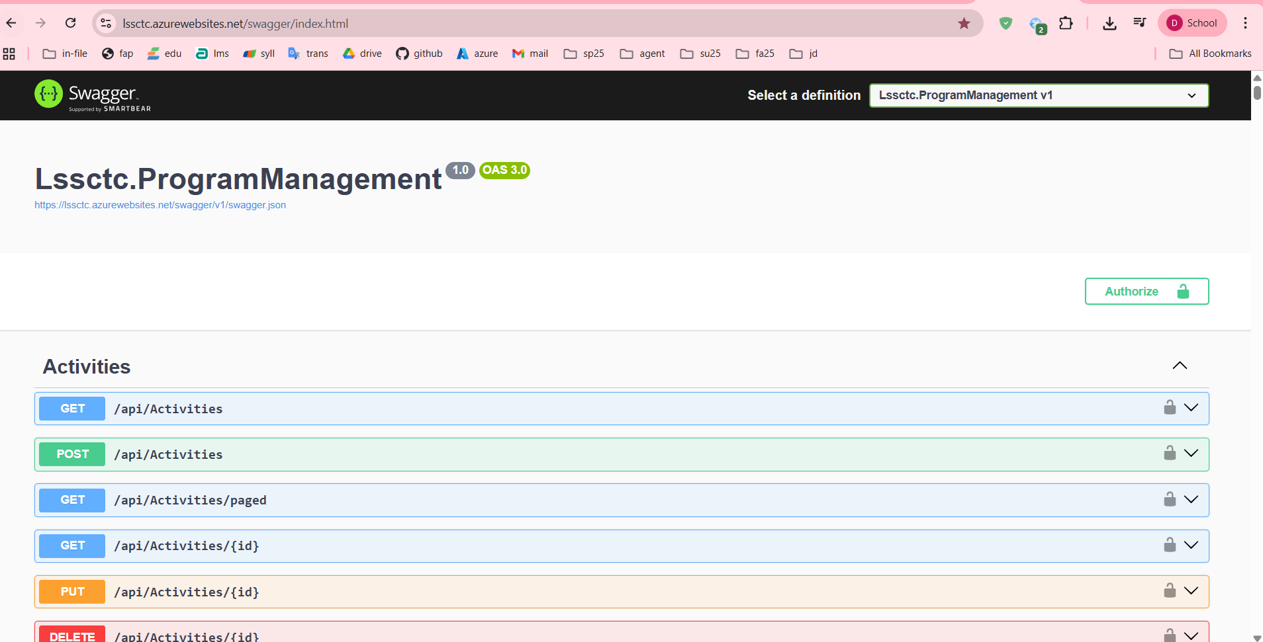

File: screenshot_swagger_ui_homepage.png

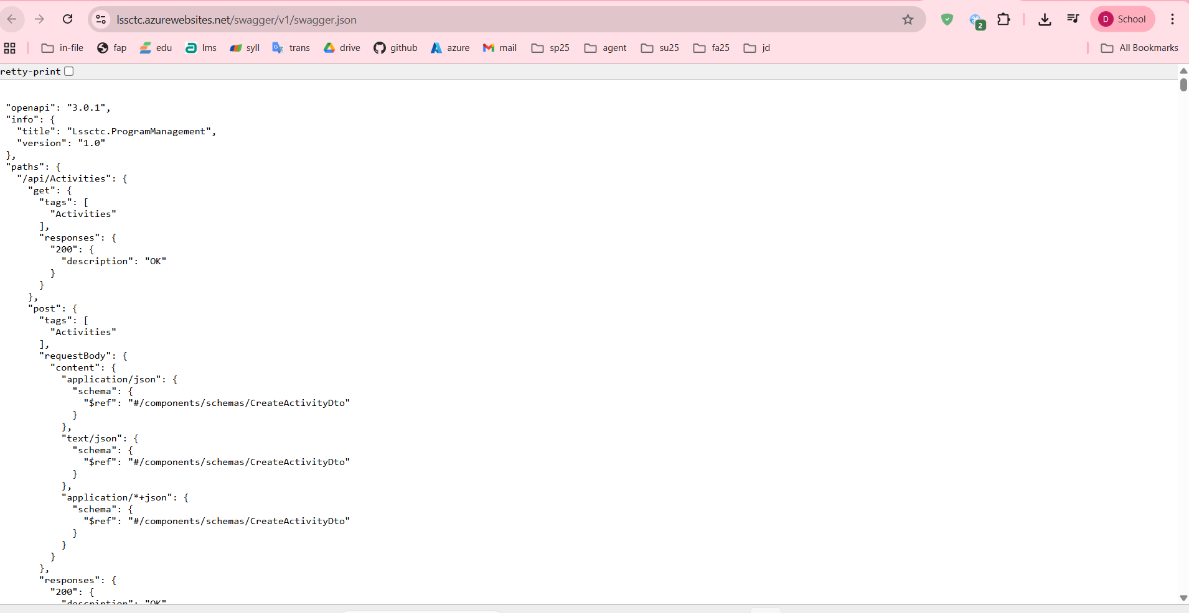

1. Test authentication endpoint:
   * Expand **POST /api/Authens/login-username**
   * Click **Try it out**
   * Enter test credentials (if seeded)
   * Click **Execute**
   * Verify 200 OK response with JWT token

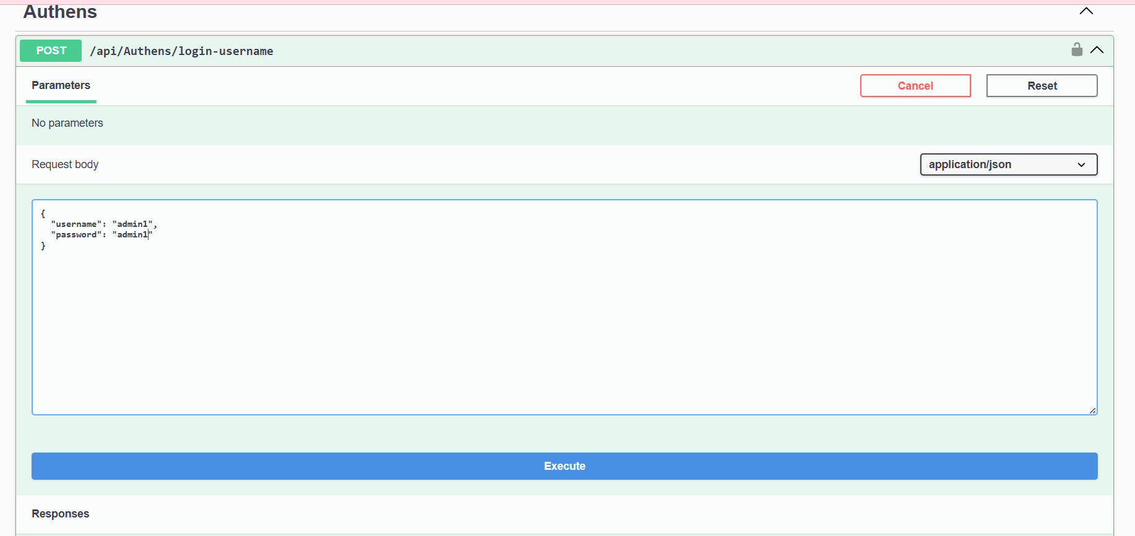

#### 2.3.4 Setup and Run Frontend Web Application

This section outlines how to configure, run, and verify the frontend client interface.

Step 1: Installation

* Navigate to the project directory and install the required dependencies.

Step 2: Environment Configuration

* Set up the connection to the backend and external services.
* Create the configuration file:
* Windows: copy .env.example .env
* macOS/Linux: cp .env.example .env
* Edit the .env file
* Optional: Google OAuth Setup To enable "Sign in with Google," create a project in the Google Cloud Console:
* Type: OAuth 2.0 Web Application
* Origin: http://localhost:5173
* RedirectURI: http://localhost:5173/auth/callback
* Action: Paste the generated Client ID into your .env file.

Step 5: Production Build (Optional)

* To prepare the application for final deployment:
* Build: Run npm run build to generate the dist/ folder.
* Preview: Run npm run preview to test the build at http://localhost:5173.

#### 2.3.5 Deployment to Production

**Backend Deployment Options:**

**Option 1: Deploy to Azure App Service**

1. Install Azure CLI
2. Login to Azure:
3. az login
4. Create App Service:
5. az webapp create --resource-group myResourceGroup --plan myAppServicePlan --name lssctc-api --runtime "DOTNET:8.0"
6. Deploy:
7. dotnet publish -c Release
8. az webapp deploy --resource-group myResourceGroup --name lssctc-api --src-path ./bin/Release/net8.0/publish. zip
9. Configure connection string in Azure Portal
10. Update JWT and Email settings

**Option 2: Deploy to Docker Container**

1. Create Dockerfile in backend project root:
2. FROM mcr.microsoft.com/dotnet/aspnet:8.0
3. WORKDIR /app
4. COPY ./publish .
5. ENTRYPOINT ["dotnet", "Lssctc.ProgramManagement.dll"]
6. Build and run:
7. dotnet publish -c Release -o ./publish
8. docker build -t lssctc-api .
9. docker run -p 5000:80 lssctc-api

**Frontend Deployment Options:**

**Option 1: Deploy to Vercel**

1. Install Vercel CLI:
2. npm install -g vercel
3. Login:
4. vercel login
5. Deploy:
6. vercel --prod
7. Configure environment variables in Vercel dashboard

**Option 2: Deploy to Azure Static Web Apps**

1. Build production bundle:
2. npm run build
3. Create Static Web App in Azure Portal
4. Connect to GitHub repository
5. Configure build settings:
   * App location: /
   * API location: (empty)
   * Output location: dist
6. Azure will automatically build and deploy on push

**Option 3: Deploy to Netlify**

1. Install Netlify CLI:
2. npm install -g netlify-cli
3. Build:
4. npm run build
5. Deploy:
6. netlify deploy --prod --dir=dist

**Database Deployment:**

**Deploy to Azure SQL Database**

1. Create Azure SQL Database in Azure Portal
2. Export local database using SSMS:
   * Right-click database → Tasks → Generate Scripts
   * Select all objects
   * Save script
3. Connect to Azure SQL Database
4. Execute script to create schema

Update connection string in backend configuration

## 3. User Manual

### 3.1 Terms and definitions

| **Term** | **Definition** |
| --- | --- |
| LSSCTC | Learner Management and 3D Simulation System for Crane Training Center |
| Admin | System administrator with full access to all features and user management |
| Instructor | Teacher/trainer who creates course content, quizzes, and evaluates trainees |
| Trainee | Student enrolled in crane operation training courses |
| Program Manager | Role responsible for curriculum design and course orchestration |
| Simulation Manager | Role responsible for managing 3D simulation components and scenarios |
| Training Program | Complete curriculum consisting of multiple courses leading to certification |
| Course | Individual training module covering specific crane operation topics |
| Section | Subdivision within a course containing organized activities |
| Activity | Learning task within a section (material, quiz, or practice) |
| Learning Material | Educational content (PDF, video, image, URL) provided to trainees |
| Quiz | Assessment containing multiple-choice or single-choice questions |
| Practice | Hands-on simulation task for skill development and evaluation |
| Class | Group of trainees enrolled in a program with scheduled sessions |
| Timeslot | Scheduled session for class instruction with date, time, and instructor |
| Enrollment | Trainee's registration and participation in a specific class |
| Activity Record | Trainee's progress and completion status for an activity |
| Quiz Attempt | Trainee's submission of a quiz with scored results |
| Practice Attempt | Trainee's completion of a practice session with performance metrics |
| Simulation Component | 3D model or asset used in crane operation simulation environment |
| Brand Model | Specific crane manufacturer and model configuration |
| JWT | JSON Web Token - authentication token for API access |
| OTP | One-Time Password - 6-digit code for password reset verification |
| WebGL | Web Graphics Library - browser technology for 3D rendering |

### 3.2 System requirements

For End Users (Trainees, Instructors):

* Operating System:
  + Windows 10/11 (64-bit)
  + macOS 10.15 (Catalina) or later
  + Linux (Ubuntu 20.04+ or equivalent)
* Web Browser:
  + Google Chrome 90+ (Recommended)
  + Mozilla Firefox 88+
  + Safari 14+ (macOS only)
  + Microsoft Edge 90+
* Internet Connection:
  + Minimum: 5 Mbps (for video streaming and general use)
  + Recommended: 10 Mbps (for 3D simulation)
* Display Resolution:
  + Minimum: 1366x768
  + Recommended: 1920x1080 or higher
* Input Devices:
  + Mouse and keyboard (required)
  + Trackpad supported but not recommended for simulation

For Simulation Features:

* RAM:
  + Minimum: 8GB
  + Recommended: 16GB
* Graphics Card:
  + Dedicated GPU with WebGL 2.0 support
  + NVIDIA GTX 1050 or equivalent
  + AMD Radeon RX 560 or equivalent
* Storage:
  + 2GB free space for cached 3D models and textures
* CPU:
  + Minimum: Intel Core i5 or AMD Ryzen 5
  + Recommended: Intel Core i7 or AMD Ryzen 7

For System Administrators:

* All of the above, plus:
* Access to SQL Server Management Studio or Azure Data Studio
* Network access to application server and database server

Remote desktop or SSH access to servers (for on-premise deployment)

### 3.3 Application Usage

#### a. Overview

The LSSCTC system is a web-based Learning Management System integrated with 3D crane operation simulation capabilities. It consists of:

1. Frontend (Web Application): React-based single-page application
2. Backend (API): .NET 8 RESTful API with JWT authentication
3. Database: SQL Server relational database
4. 3D Engine: WebGL-based simulation environment (planned)

#### b. Feature 1: Authentication & User Management

Purpose: Secure user authentication with multiple login methods and role-based access control

Available Functions:

1. Login with Username/Password
2. Login with Email/Password
3. Login with Google OAuth
4. Password Reset (OTP-based)
5. Logout

Profile View and Update

Import Users from Excel (Bulk Creation)

Create User with Auto-Email Notification

Deactivate/Reactivate User (Soft Delete)

#### c. Feature 2: Admin - Course Management

Purpose: Create, organize, and manage training courses

Available Functions:

1. View All Courses (with pagination, search, sort)
2. Create New Course
3. Edit Course Details
4. Delete Course (soft delete)
5. Assign Course to Programs

View Course Enrollments

Manage Course Sections & Materials (Curriculum)

Configure Course Certificate Template

#### d. Feature 3: Admin - Class Management

Purpose: Organize trainees into classes, assign instructors, and manage schedules

Available Functions:

1. View All Classes
2. Create New Class
3. Edit Class Details
4. View Class Enrollments
5. Approve/Reject Enrollments
6. Manage Class Timeslots (Schedule)

Assign Instructors

Configure Final Exam Structure & Weights

Import Class Members via Excel

Update Class Status (Planning/Open/Closed)

#### e. Feature 4: Instructor - Quiz Management

Purpose: Create assessments to evaluate trainee knowledge and understanding

Available Functions:

1. Create Quiz with Questions
2. Import Quiz from Excel Template
3. Edit Quiz and Questions
4. Delete Quiz
5. Assign Quiz to Activity

View Quiz Attempts and Results

***Create Quiz:***

Step-by-Step Instructions:

1. Login as Instructor
2. Navigate to Instructor Dashboard
3. Click "Quizzes" in sidebar

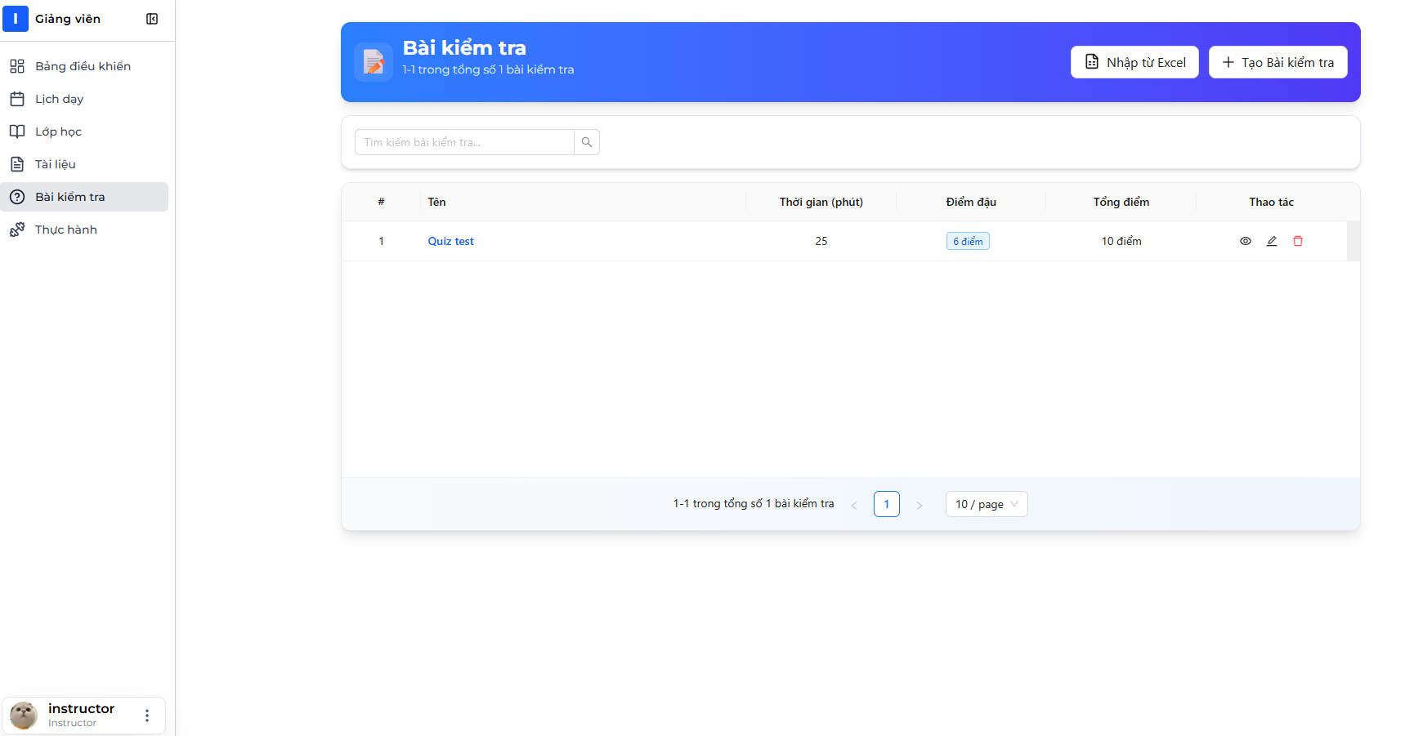

1. Quizzes list page displays showing your created quizzes



1. Click "Create New Quiz" button

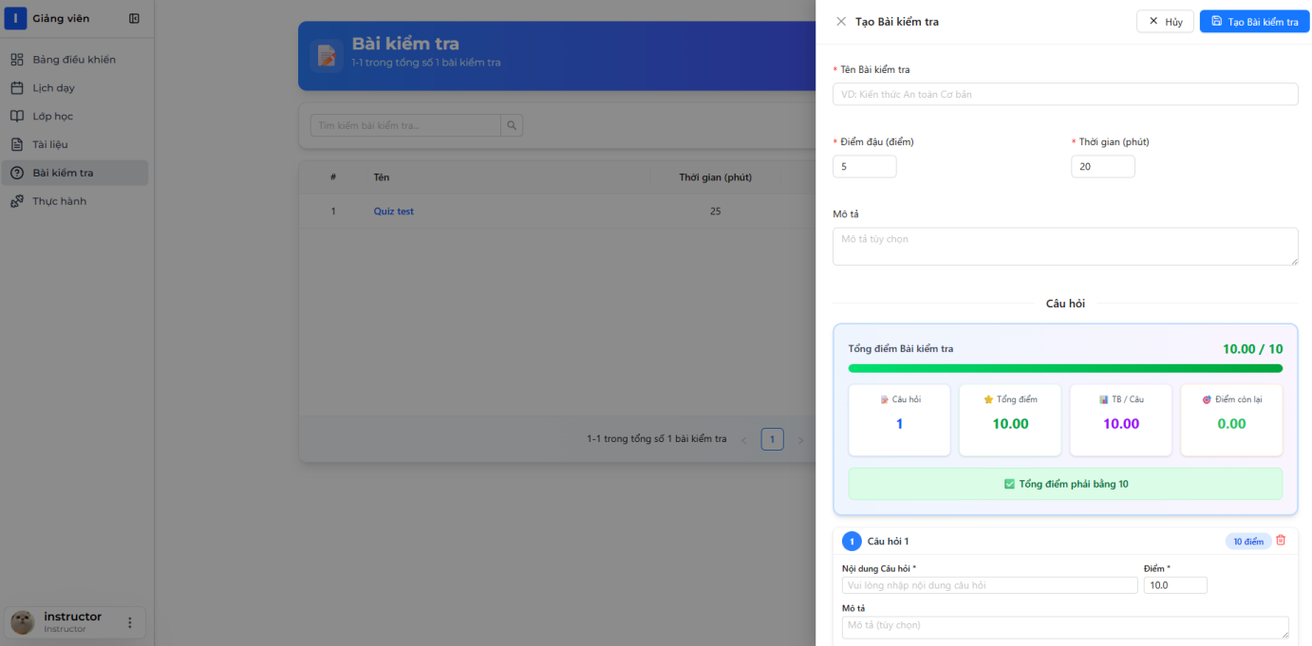

1. Quiz creation form opens (may be multi-step)

Step 1: Quiz Basic Information

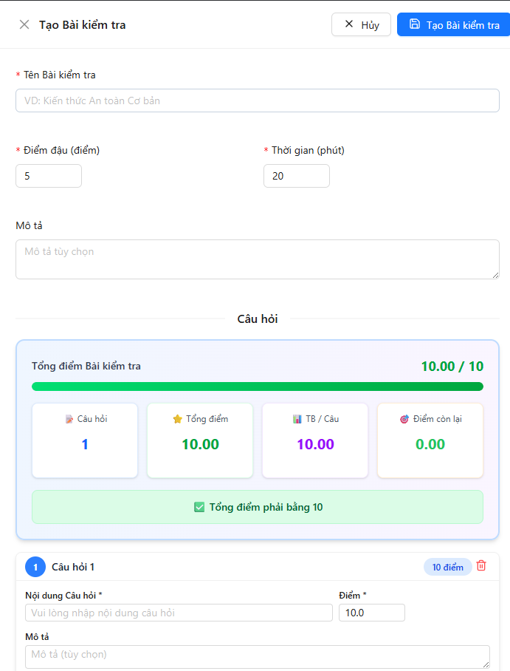

1. Fill in quiz information:
   * Quiz Name: "Mobile Crane Safety Assessment"
   * Description: "Test your knowledge of crane safety procedures"
   * Duration: 30 minutes
   * Passing Score: 7
2. Click "Next"

Step 2: Add Questions

📷 INSERT SCREENSHOT HERE: Add Questions Section

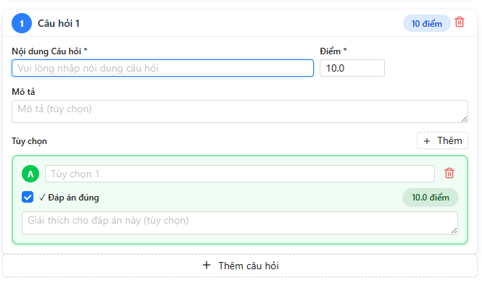

1. Click "Add Question" button
2. Question form appears



1. Fill in question details:
   * Question Text: "What is the safe minimum distance from a power line for crane operations?"
   * Score Points:10
   * Explanation: "Regulations often require at least 10 meters depending on voltage."
2. Add Options:
   * Click "Add Option" button for each option

📷 INSERT SCREENSHOT HERE: Add Option Interface

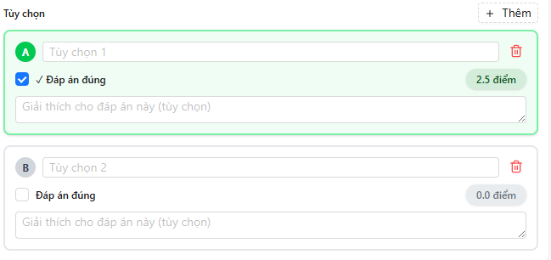

1. Enter options:
   * Option 1: "1 meter" (not correct)
   * Option 2: "3 meters" (not correct)
   * Option 3: "10 meters" (check "Is Correct")
   * Option 4: "50 meters" (not correct)

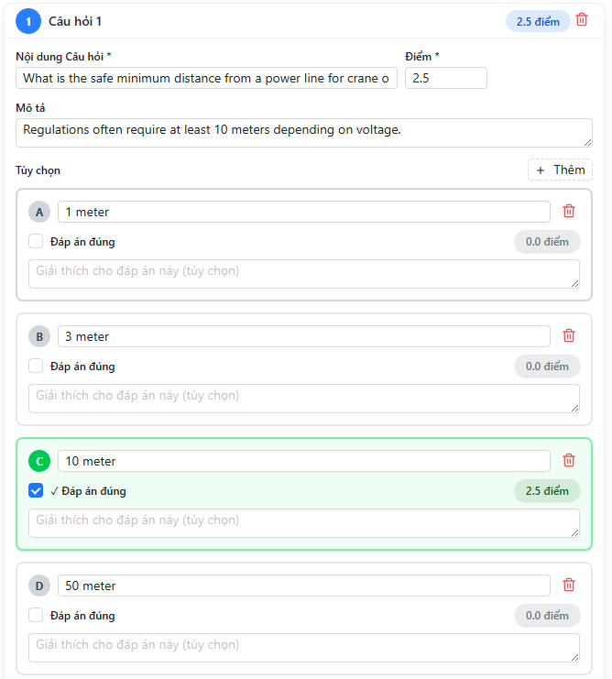

1. Click "Save Question"
2. Question is added to quiz questions list

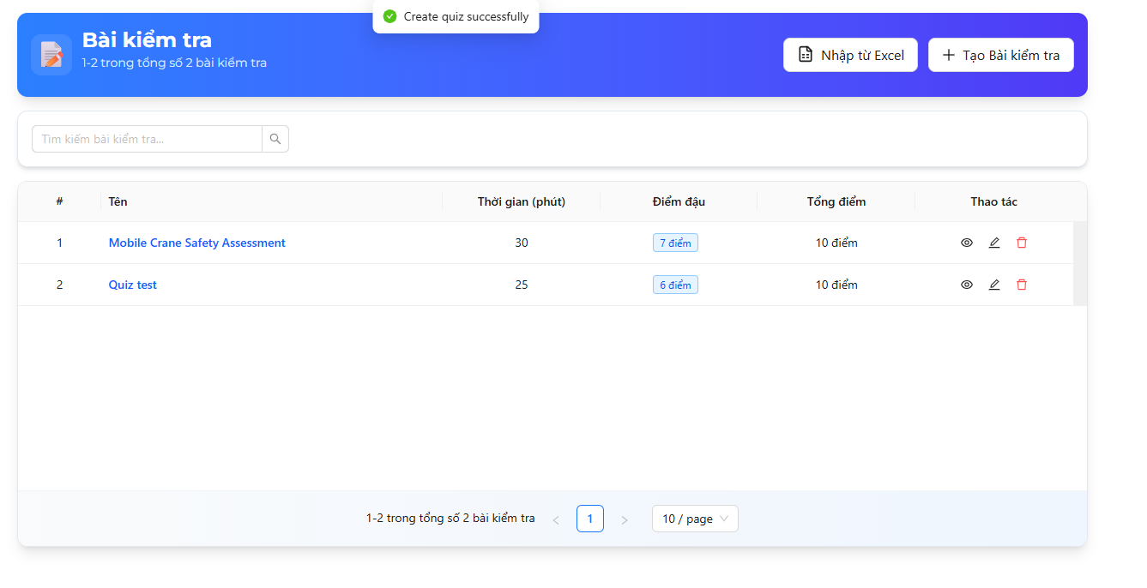

1. Repeat steps 9-15 to add more questions
   * Add at least 2-10 questions per quiz



1. Review Quiz:
   * Check all questions are added
   * Verify total points
   * Ensure at least one correct option per question
2. Click "Save Quiz" button
3. Success message: "Quiz created successfully"



***Import Quiz:***

Import Quiz from Excel

Step-by-Step Instructions:

1. Download Excel template first:
   * Navigate to Quizzes page
   * Click "Import Quiz" dropdown
   * Select "Download Template"

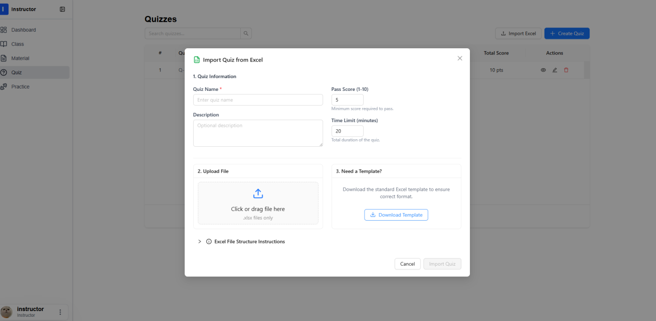

1. Template Excel file downloads

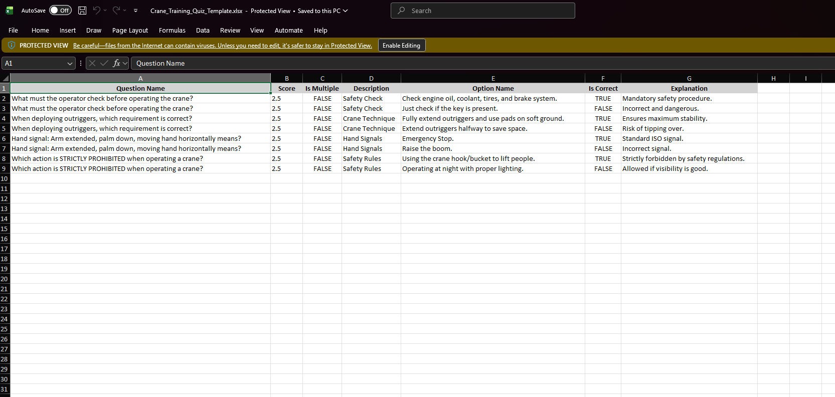

1. Fill in template:
   * Each question can have multiple rows (one per option)
   * Question Name must be same for all options of same question
   * Is Multiple: true/false
   * Is Correct: true/false (only ONE true for single choice)



1. Save Excel file as .xlsx format
2. Return to Quizzes page
3. Click "Import Quiz" → "Import from Excel"

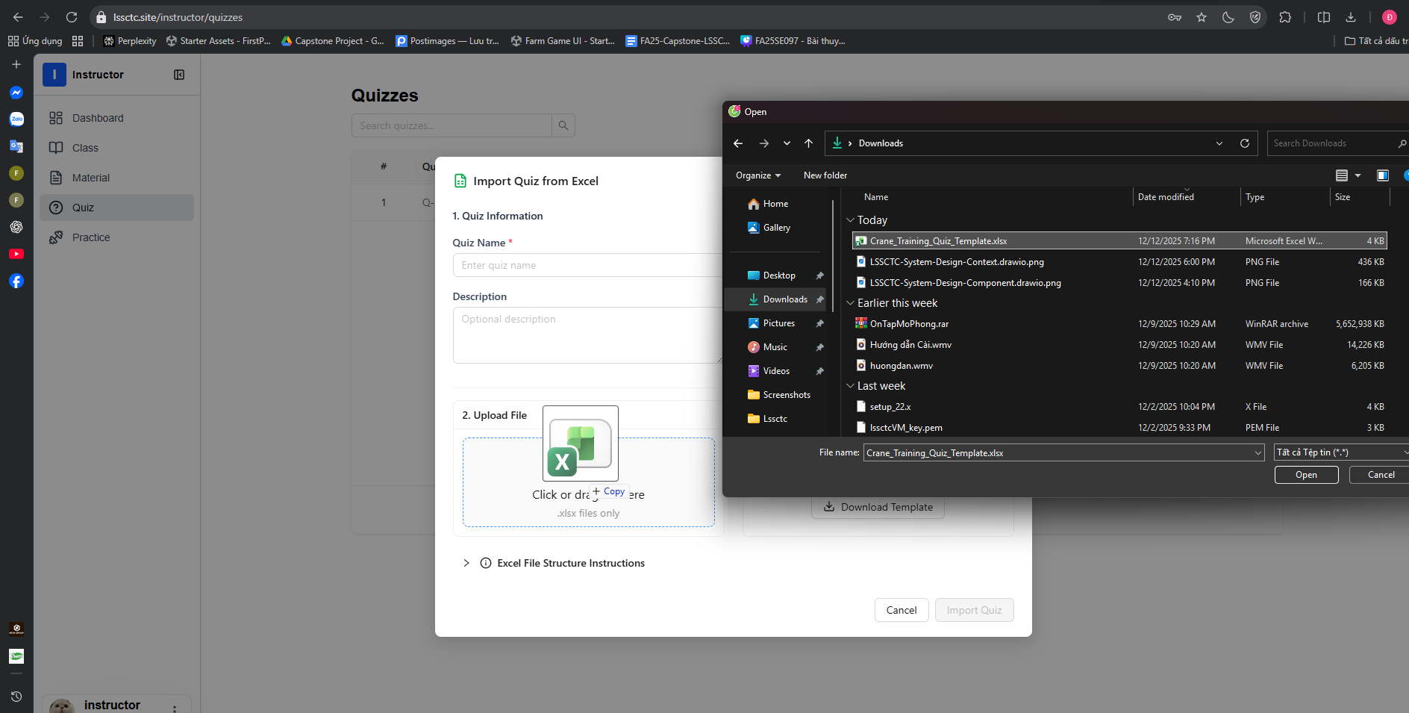

1. Drag file into drop zone or click "Browse Files"
2. Select your filled Excel file
3. File name appears in dialog

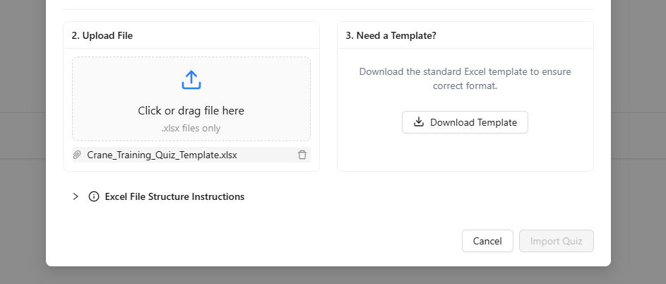

#### f. Feature 5: Simulation Practice

1. Download file exe

* Downloading the File: Click the "Tải Mô phỏng" (Download Simulator) button to download the .exe installer.
* Connection Stability: Ensure you have a stable internet connection (at least 10 Mbps recommended) throughout the download process to avoid file corruption.
* Download Failure: If the download fails or the file does not open, delete the partial file and restart the download from the beginning.

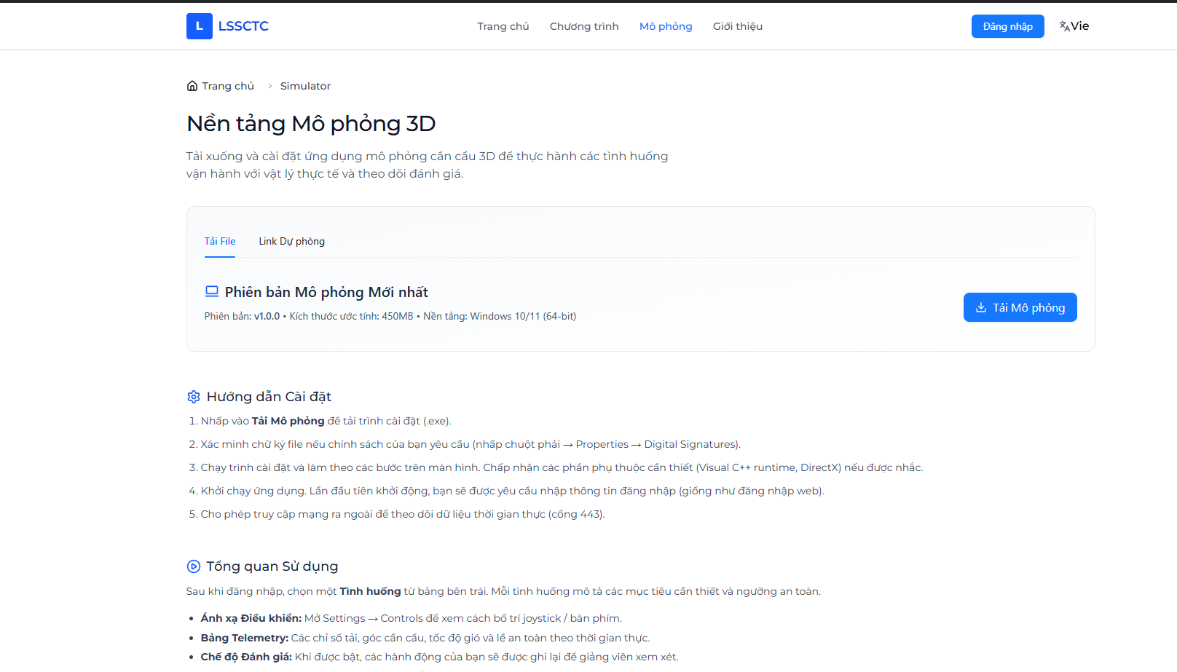

2. Open CraneSimulator.exe file

* Security Warnings: When launching the application, your operating system (Windows) may display a security alert such as "Windows protected your PC" or "Unknown Publisher." * Action: Click "More info" and select "Run anyway" to bypass the warning.

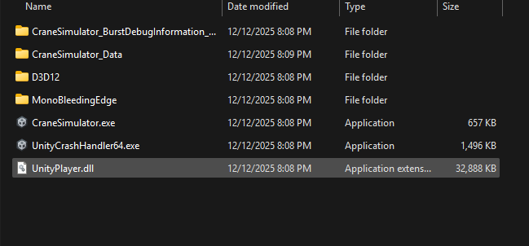

3. Login with username, password

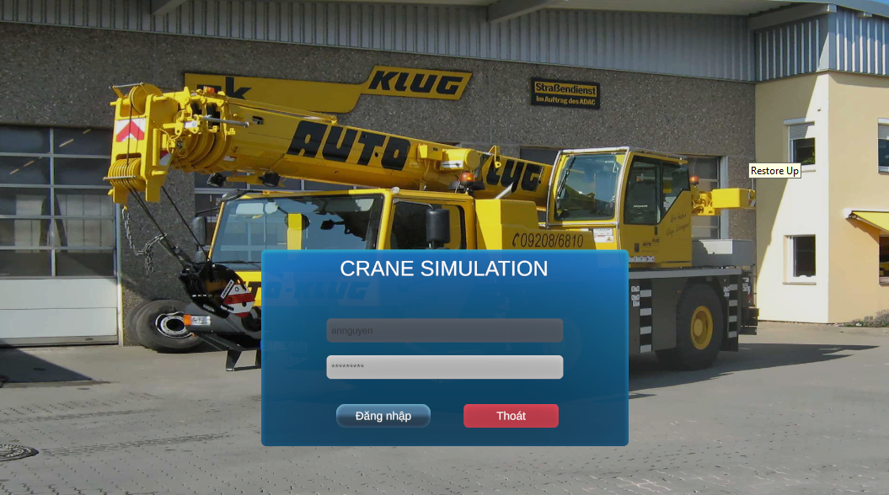

3.1. Login Fail.

* If Login fail, please try to login again with correct username and password

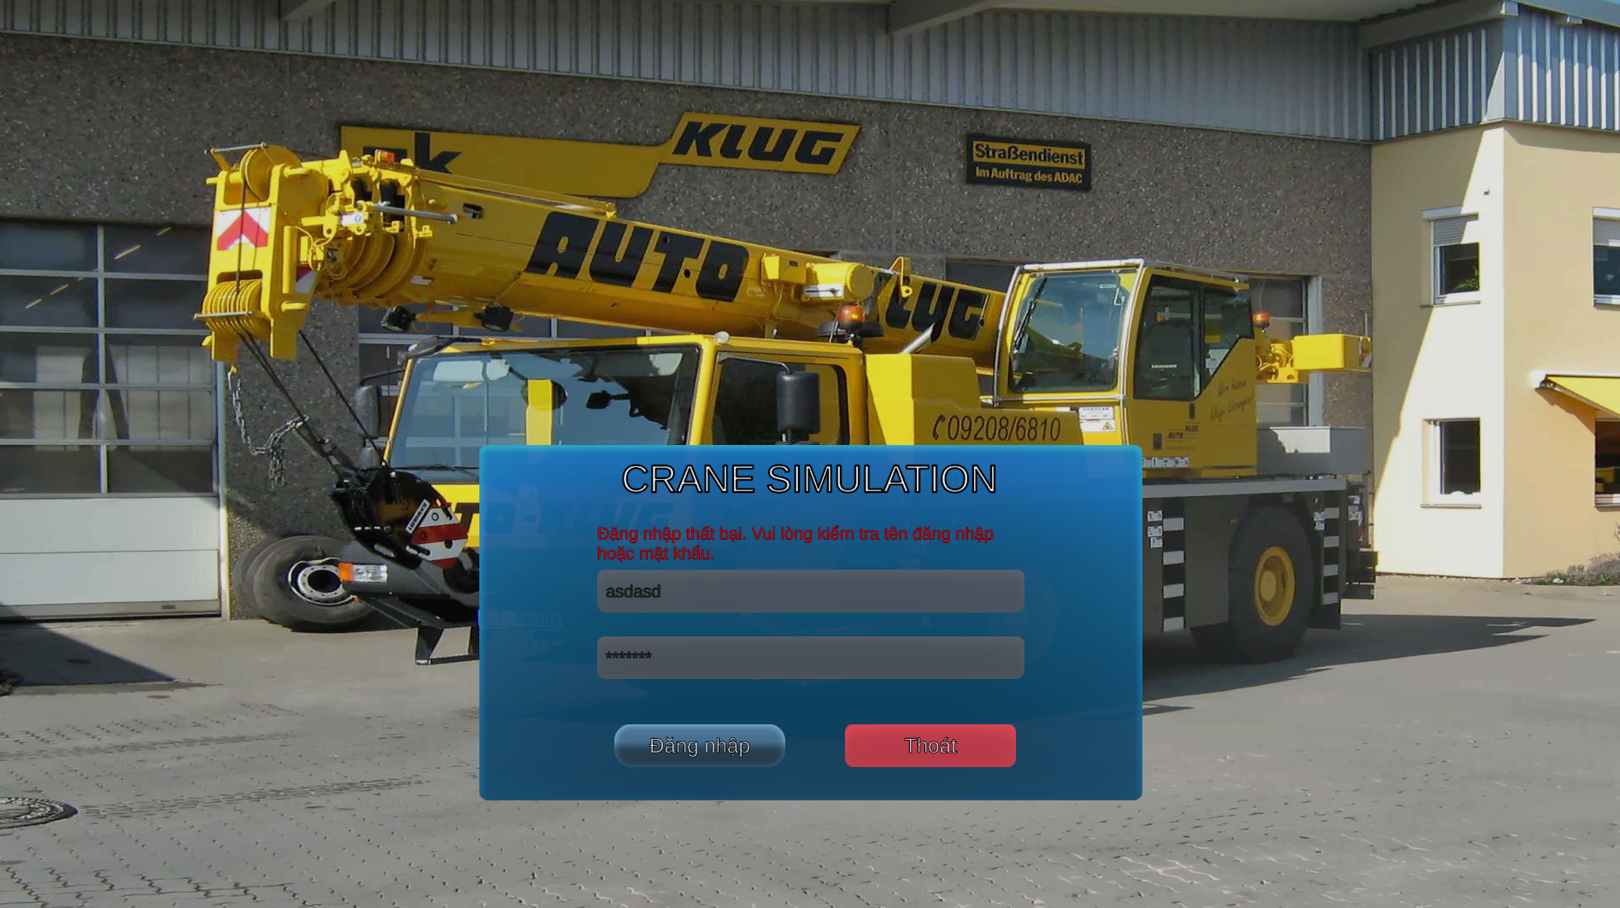

4. Select practice mode.

* Once logged into the LSSCTC Simulator, you will be presented with two distinct modes. The availability of these modes depends on your current enrollment status and the permissions granted by your Instructor.

4.1. "Bài Tập" (Practice) Mode

* **Purpose:** To allow trainees to familiarize themselves with the crane controls without the pressure of a final score.
* Accessibility: This mode is usually unlocked automatically once you are assigned to a class.
* Repetition: You can restart this mode as many times as needed to perfect your practice.

4.1. "Kiểm Tra" (Exam) Mode

* Access Requirements:
  + Instructor Activation: This mode will only be visible if an Instructor or Admin has scheduled and activated an exam for your specific class.
  + Access Code (Security): To enter the exam, you must provide a unique Access Code. This code is provided only by your Instructor or the Program Manager at the beginning of the testing session.
* Limit Attempt: Unlike Practice Mode, Exam Mode may limit the number of attempts you can make, and your performance metrics (score and time) are sent directly to the Instructor's dashboard.
* Technical Safety: Ensure you have a stable connection before starting; if the application crashes or you lose internet, you must immediately contact your Instructor to reset your session.

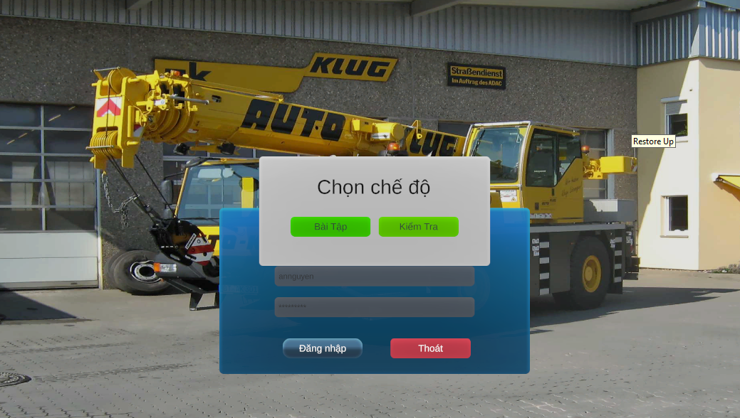

5. Select Class.

After choosing your desired mode (Practice or Exam), you must specify the training group you are participating in to ensure your progress is recorded correctly.

* Class Selection Logic: The system will display a dropdown list of Classes that you are currently enrolled in.
* Enrollment Requirement: A class will only appear in this list if your Enrollment has been officially Approved by the Admin or Instructor.
* Course Coordination: Each class is tied to a specific Training Program or Course; ensure you select the one corresponding to your current curriculum.

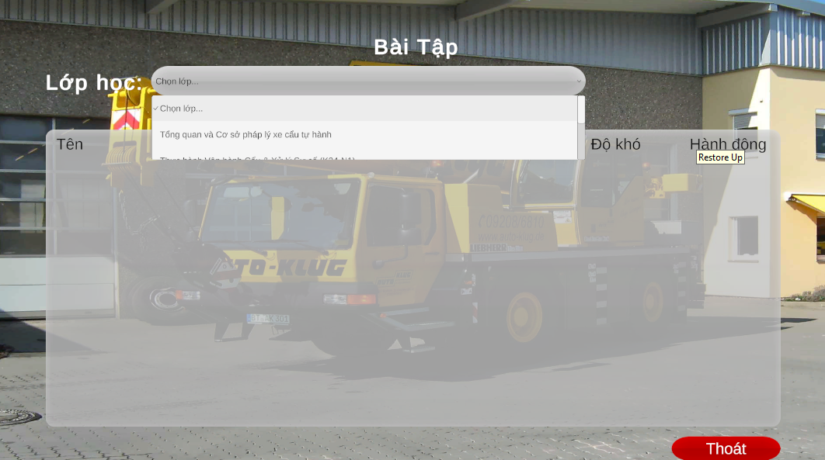

6. Select practice to start.

After selecting the correct class, the system will display the list of available simulation scenarios assigned to that specific group. This step ensures you are entering the correct training environment for your current module.

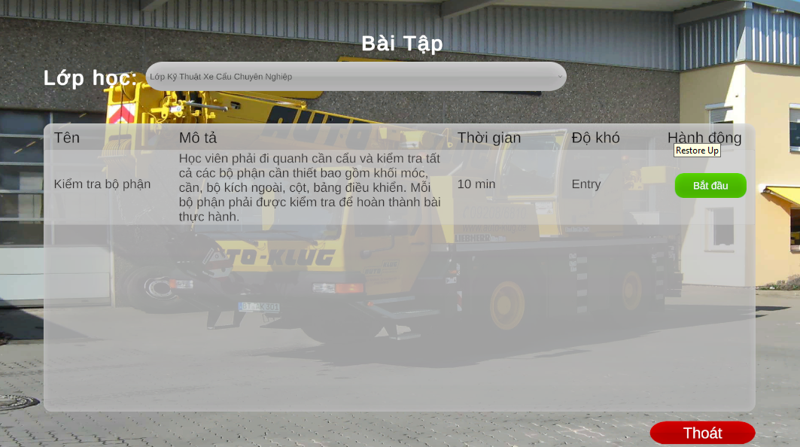

7. Read practice guide before doing the practice.

Once you select a scenario, a Practice Guide overlay will appear. This is a critical preparation phase—do not skip it, as it contains the specific rules for the simulation environment.

7.1 Key Information to Review

* Operational Objectives: Understand the exact start and end points of the cargo (e.g., from the ground to the truck bed).
* Safety Constraints: Review the "ZigZac" path requirements; the system will not count progress if you deviate from this specific path.
* Penalty Rules: Be aware that every time the cargo or hook touches a pole, your score will be automatically reduced by 0.5 points.

7.2 Understanding Phase Transitions

* Phase 1: Focuses on navigating the obstacle course (the ZigZac poles).
* Phase 2: Activates only after Phase 1 is completed successfully; the target text will change, signaling you to move the cargo to the final drop-off point (the truck).

7.3 Operational Tips

* Lever Identification: Use the guide to familiarize yourself with which levers control the boom, the winch, and the rotation before you engage them with the "F" key.
* Visual Cues: Look for "Target Point" in the 3D world which indicate where the cargo needs to be positioned next.

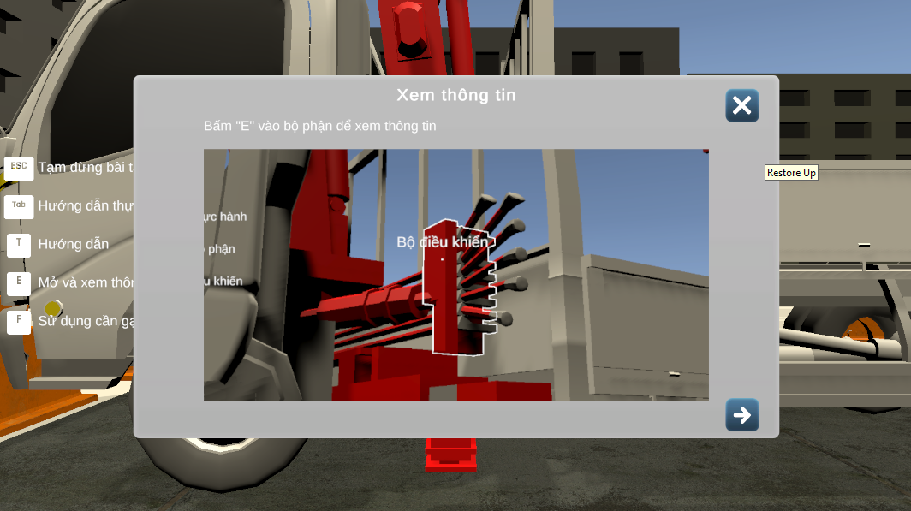

8. Important key when doing practice.

Operating the crane simulator requires precise coordination between keyboard inputs and visual cues. Familiarize yourself with these essential controls before engaging the crane components.

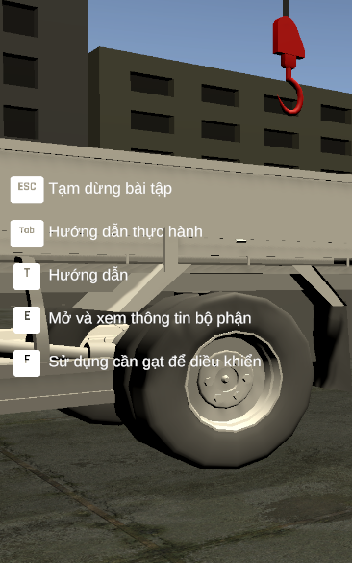

9. Lever Identification and Focus.

Before engaging the crane, you must identify which control component you wish to operate. The simulator uses a proximity-based "Focus" system to prevent accidental movements.

* First-Person Interaction: Use your mouse to look around the crane cabin or control station.
* Visual Hover: Move your crosshair (reticle) directly over a specific crane lever.
* Name Recognition: Wait for the Lever Name to appear on your screen (e.g., "Main Hoist," "Boom Luffing," or "Swing Control").
* Contextual Awareness: Different levers correspond to different 3D components of the crane; always verify the lever name matches your intended action before pressing the interaction key.

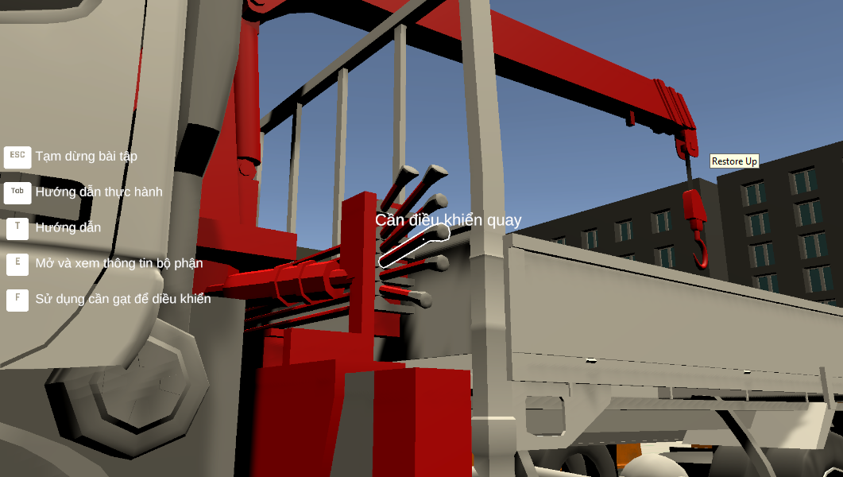

10. Press “F” to the lever to control the Crane with Corresponding components.

Once the name of the lever is visible, you are ready to begin the operation.

* Engage: Press the "F" key to lock your focus onto that specific lever
* Dynamic Controls: As soon as you engage a lever, the Hint Keys at the bottom right will update to show you the movement controls for that specific part of the crane (e.g., Forward/Backward or Left/Right).
* Switching Controls: To move to a different lever, press "F" again to release the current one, then repeat the hover process for the next control.

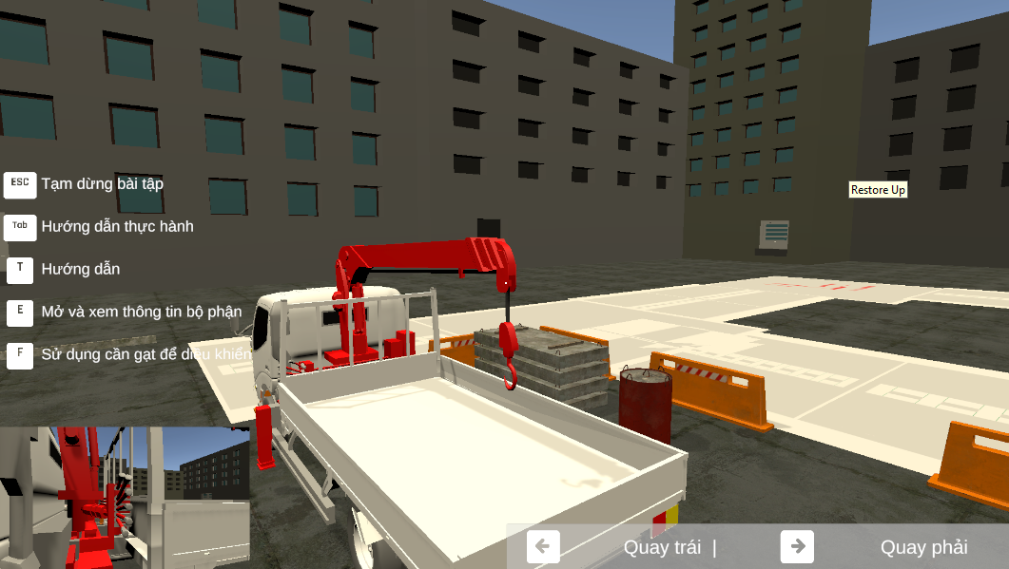

11. Hints.

* Control Labels: Use the hint key display on the bottom right of your screen as a constant reference for operating the crane's components.
* Real-time Guidance: These hint keys will change dynamically based on which lever you have selected, helping you move the crane accurately toward the target cargo.

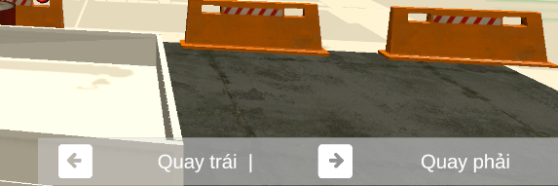

12. Operating the Crane Using Dynamic Hints

The simulator provides real-time guidance to help you master the crane's complex movements. The hint system ensures you always know which keys correspond to your current lever selection.

* Dynamic Mapping: Once you have engaged a lever with the "F" key, look at the bottom right corner of your screen.
* Contextual Control: The hint panel will update instantly to show you the specific keys (e.g., Arrow Keys or W/A/S/D) required to move the current component (Boom, Swing, or Hoist).
* Precision Movement:
  + Tap vs. Hold: For fine adjustments when approaching a target, tap the keys lightly.
  + Coordinated Control: While only one lever is controlled at a time, you must sequence your movements (lifting, then swinging, then luffing) to maintain a smooth path.

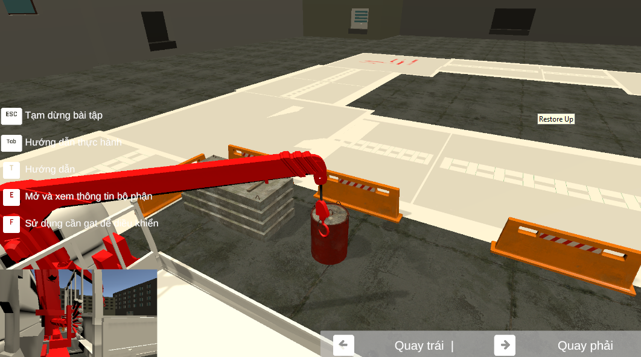

### 13. Monitoring Performance Metrics.

As you use the hint keys to move the crane, stay aware of your operational status:

* Score and Timer: These are visible at the top right of the screen.
* Penalty Awareness: Remember that jerky movements or over-swinging can lead to collisions with the ZigZac poles, resulting in a 0.5 point deduction per hit.

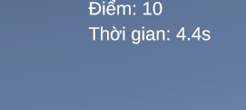

### 14. Move the crane to the target cargo.

* Identify Destination: Use the camera to locate the Target Cargo in the simulation area.
* Approach: Move the crane steadily until the hook block is centered over the load, preparing for the attachment phase.

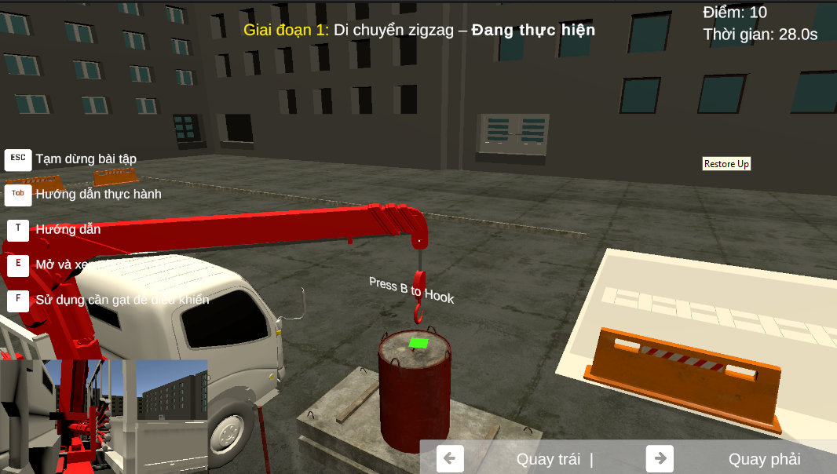

### 15.Press “B’ to attach the cargo to the hook block.

* Attachment Protocol: Lower the hook block until it is within the attachment radius of the cargo.
* Locking: Press "B" to secure the cargo to the hook.

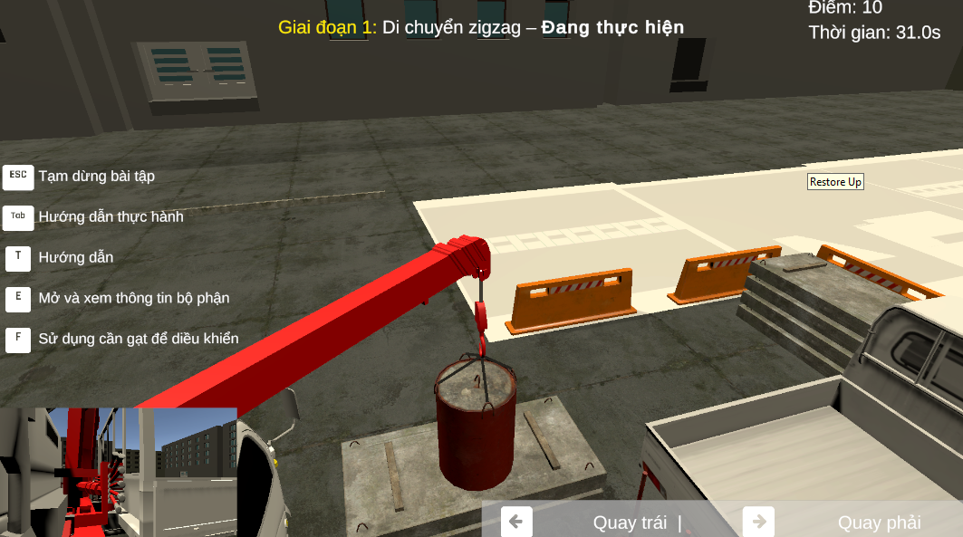

### 16.Lift the cargo up and doing the practice.

Once the cargo is securely attached using the "B" key, you must perform a controlled lift to begin the maneuver.

* Vertical Control: Use the Hoist/Winch lever to lift the cargo vertically.
* Safety Clearance: Lift the cargo to a height that clears ground obstacles but remains low enough to maintain a low center of gravity.
* Swing Dampening: Wait for any initial pendulum swing to settle before starting horizontal movement to avoid immediate collisions with the first set of poles.
* Telemetry Monitoring: Check the top right of the screen to ensure the weight load is balanced and the timer has officially started for the practice session.

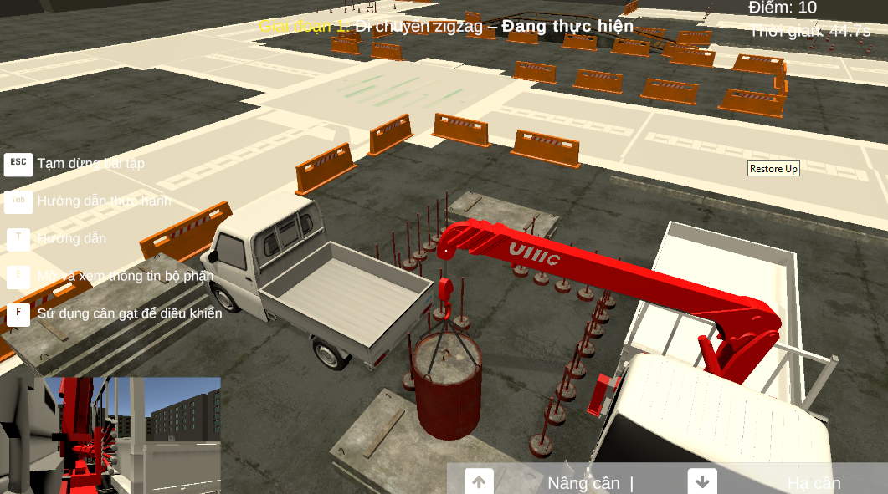

### 17. Move the Cargo to the target point.

The ZigZac practice is divided into two distinct phases. You must complete the objective of Phase 1 before the system will allow you to proceed to Phase 2.

**17.1. “Ziczac” practice target.**

**17.1.1. “Ziczac” practice phase 1 target.**

* **Primary Goal: You must navigate the suspended cargo through the pole course following the designated zigzag trajectory.**
* **Path Accuracy: The cargo must stay within the zigzag boundary; if you skip a section of the path, the maneuver will not be counted as valid.**
* **Landing Zone: Phase 1 concludes when you move the cargo to the first target point and lower it to the designated surface.**
* **Collision Monitoring: Throughout this phase, ensure the cargo does not touch the poles, as each contact results in a 0.5 point deduction from your score.**

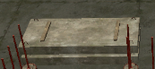

**17.1.1. “Ziczac” practice phase 2 target.**

* **Transition: Once Phase 1 is completed, the objective text on your screen will update, signaling the start of Phase 2.**
* **Primary Goal: Move the cargo from the Phase 1 landing zone to the back of the transport truck (Target 2).**
* **Precision Control: Carefully align the cargo over the truck bed using the hint keys to coordinate swing and boom movements.**
* **Completion: Lower the cargo onto the truck bed before opening the menu to submit your results.**

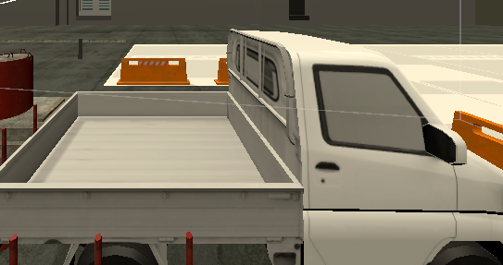

### 17.2. Cargo positioning practice target.

This scenario focuses exclusively on your ability to perform precise vertical and horizontal adjustments to center a load.

* Primary Goal: Move the cargo from its starting position and land it directly in the center of the target circle.
* Accuracy Metrics: The system calculates your final score based on how close the center of the cargo is to the center point of the circle.
* Vertical Control: Use the Hoist/Winch lever to ensure the cargo does not sway as you lower it toward the ground.

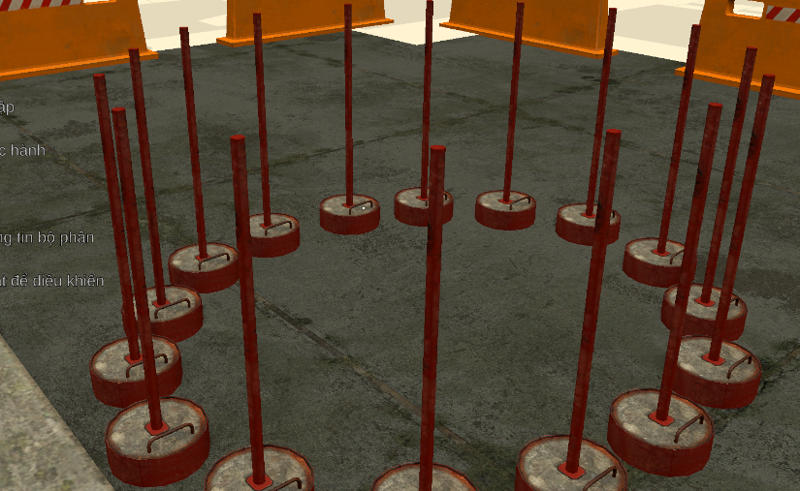

### 18. The path must be in the zigzag, if it's not it won’t be counted.

The simulator is programmed with a strict path-tracking algorithm. To pass the evaluation, you must adhere to the designated route.

* Non-Negotiable Trajectory: The cargo must pass between every set of poles in the specific "ZigZac" sequence.
* Checkpoint System: The system utilizes invisible checkpoints; if you attempt to "shortcut" the course by bypassing a pole, the maneuver will not be recognized, and the task will not be marked as complete.
* Validation Logic: Progress is only recorded when the cargo centers through each gap; failing to follow the sequence means the final phase will not trigger.

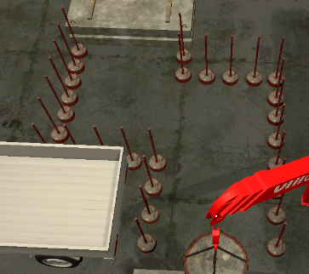

### 19. Precision Handling and Penalty System

Safety is the highest priority in crane operation. The simulator enforces this through a real-time scoring deduction system.

* Collision Detection: The physics engine detects any contact between the cargo, the hook block, or the crane’s boom and the boundary poles.
* Scoring Penalties: Each instance of contact results in an immediate -0.5 point deduction from your total performance score.
* Swing Control: You must manage the "pendulum effect" by making small, counter-movements with the levers; excessive cargo swaying is the primary cause of pole collisions.
* Monitoring: Keep a constant eye on the top-right HUD to track your current score during the maneuver.

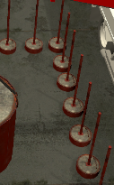

### 20. Objective Transition: Phase 1 to Phase 2.

The simulator provides clear visual and textual feedback when a major milestone is reached.

* State Change: Once the cargo successfully clears the final "ZigZac" checkpoint, the system will automatically transition to Phase 2.
* Visual Notification: The instruction text on your screen will update to reflect the new objective.

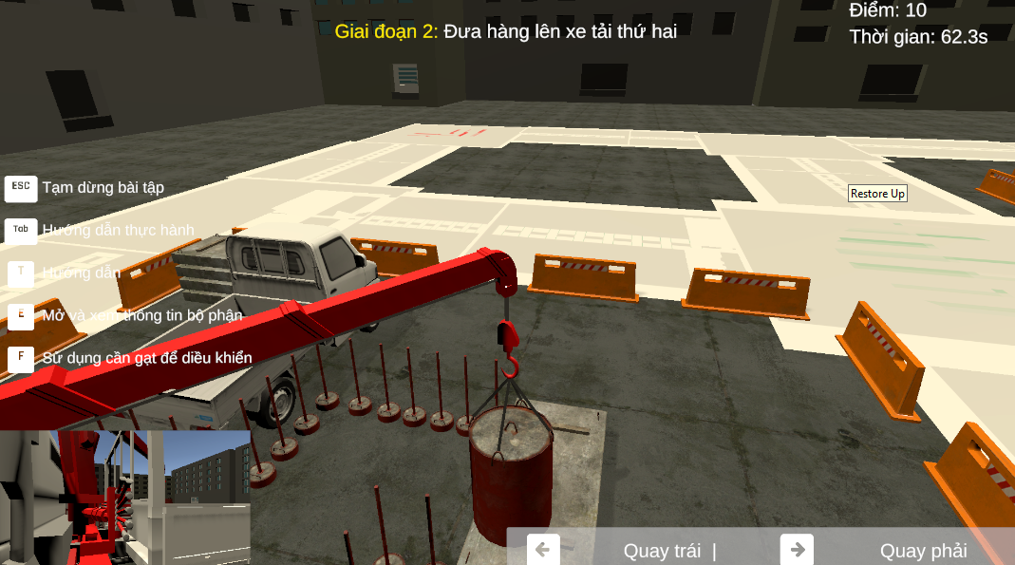

### 21. Move the cargo to the back of the truck to finish the practice.

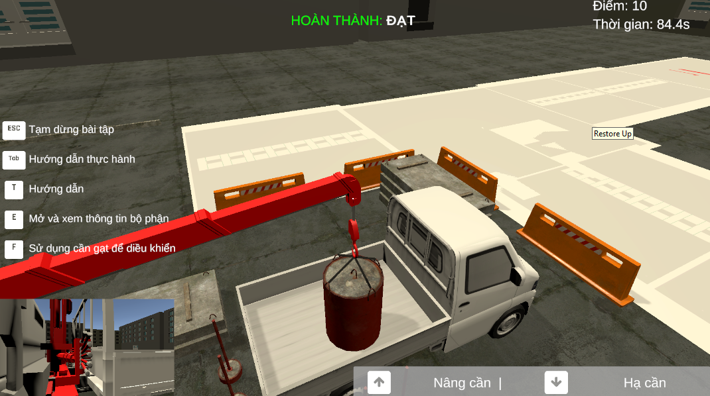

### 22. Final Review and Process Completion.

* Opening the Menu: After placing the cargo, press "ESC" on your keyboard to pause the simulation and open the settings/submission menu.
* Submission ("Nộp bài"): Click the "Nộp bài" button to finalize your attempt and transmit your score, time, and penalty data to the instructor's dashboard.

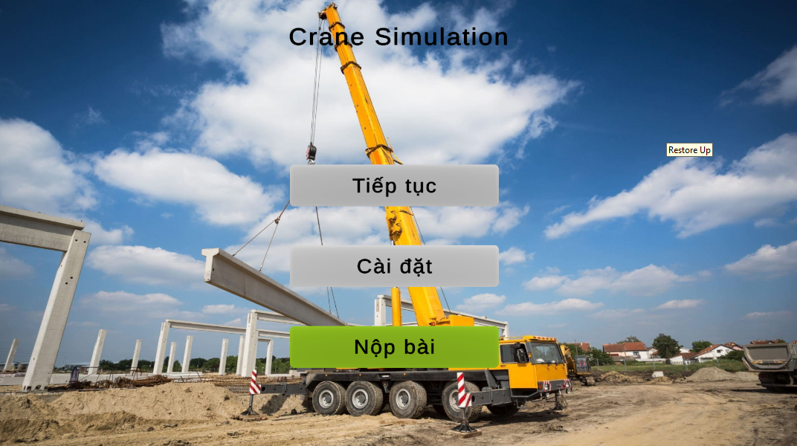

#### g. Feature 6: Simulation Manager Portal

**Overview:** This feature is the control center for the simulation ecosystem. It allows the **Simulation Manager** to configure physics parameters, manage 3D assets, and design training scenarios. These configurations directly synchronize with the Desktop Client to ensure accurate simulation behavior.

**Actor:** Simulation Manager **Pre-condition:** User must be logged in successfully with the Simulation Manager role.

#### 6.1 Manage Brand Models (Quản lý Thương hiệu & Model)

* **Description:** Defines the technical specifications (physics profiles) of different crane models. The Unity Client uses these parameters to calculate real-time physics limits.
* **Trigger:** Select **"Thương hiệu và model"** (Brand Models) from the Sidebar.
* **URL:** /simulation-manager/brand-model

**Usage Steps:**

1. **View List:** The interface displays a table of registered crane models.
2. **Create New Model:**
   * Click the **"Tạo mới"** (Create) button on the top right.
   * **[Action]:** A drawer form appears.
   * Input the required fields:
     + **Tên Model** (Model Name): e.g., *SCC550A*.
     + **Tải trọng tối đa** (Max Lifting Capacity): e.g., *55 tons*.
     + **Bán kính tối đa** (Max Radius): e.g., *40m*.
   * Click **"Lưu"** (Save) or **"Xác nhận"** (Submit) to finish.
3. **Edit/Delete:** Click the **"Chỉnh sửa"** (Edit icon) or **"Xóa"** (Delete icon) on specific rows.

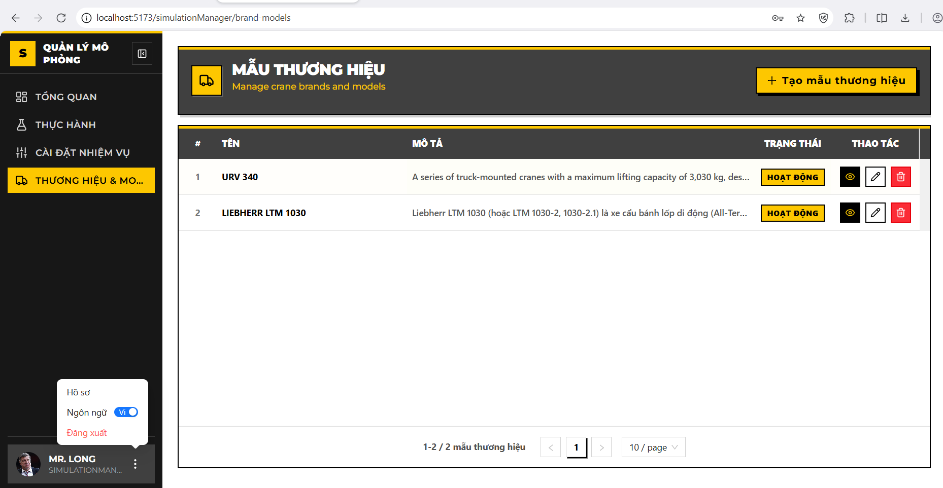

### 6.1.2 Create New Brand Model (Tạo mới Thương hiệu & Model)

**Description:** Provides a drawer interface for Simulation Managers to register a new crane model identity (e.g., KATO, SANY) into the system. This establishes the brand profile before physical parameters are configured.

**Trigger:** Click the **"Thêm mới"** (Create) button (icon dấu cộng **+**) located at the top-right corner of the management table.

**Usage Steps:**

1. **[Action]:** A drawer form slides in from the right side of the screen titled **"THÊM MỚI THƯƠNG HIỆU"** (Create Brand Model).
2. **Input the required fields:**
   * **Tên thương hiệu (Brand Name):**
     + *Input:* Text field.
     + *Validation:* Required, unique in the system (Duplicate Check).
     + *Example:* "SANY SCC550A".
   * **Mô tả (Description):**
     + *Input:* Text Area.
     + *Validation:* Optional, max 500 characters.
     + *Example:* "Cẩu bánh xích 55 tấn - Model tiêu chuẩn 2024".
   * **Trạng thái (Status):**
     + *Input:* Toggle Switch.
     + *Default:* Active (Hoạt động).
3. **Submission:** Click **"Lưu"** (Save) to submit the data to the server (POST /api/BrandModels).

**System Logic (Backend Verification):**

* **Name Normalization:** The system automatically trims whitespace (e.g., " KATO ") before saving.
* **Integrity Check:** If the entered name already exists, the system returns a 400 Bad Request: *"Tên thương hiệu đã tồn tại"* (Brand name already exists).

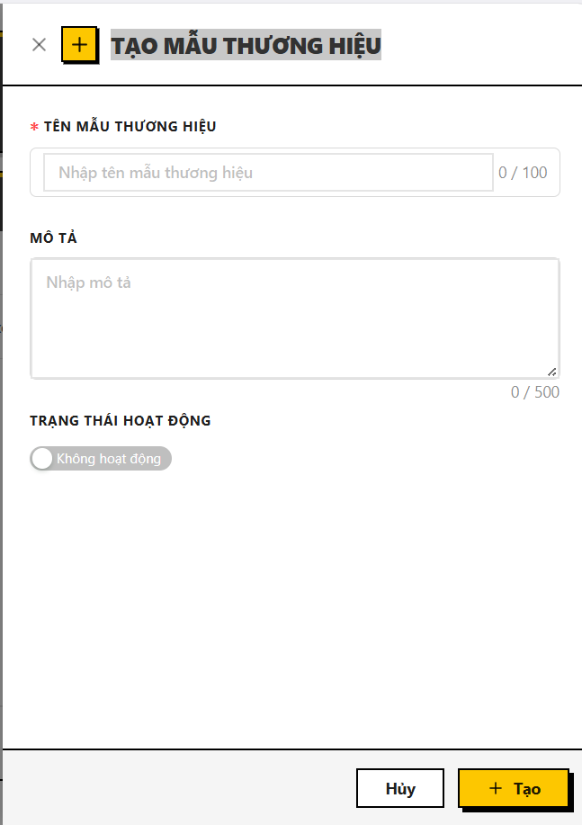

### 6.1.3 Edit Brand Model (Sửa mẫu thương hiệu)

**Description:** Allows authorized users to modify the details of an existing crane model. This function ensures that any updates to the brand identity (Name, Description) do not violate system integrity rules.

**Trigger:** Click the **"Chỉnh sửa"** (Edit - icon bút chì) button on a specific row in the Brand Model list.

**Usage Steps:**

1. **[Action]:** The drawer form slides in from the right, titled **"CẬP NHẬT THƯƠNG HIỆU"** (Edit Brand Model).
2. **Data Population:** The form automatically pre-fills with the selected model's current information:
   * **Tên thương hiệu (Brand Name):** Displays current name (e.g., "SANY SCC550A").
   * **Mô tả (Description):** Displays current description.
   * **Trạng thái (Status):** Shows the current Active/Inactive switch state.
3. **Modification:** User updates the desired fields.
   * *Input:* Text field / Text Area / Switch.
   * *Validation:* Standard validation rules apply (Required, Max length).
4. **Submission:** Click **"Cập nhật"** (Save/Update) to commit changes to the server (PUT /api/BrandModels/{id}).

**System Logic (Backend Verification):**

* **Existence Check:** The system verifies if the record exists and has not been deleted.
* **Self-Exclusion Duplicate Check:** The system checks if the new name exists in the database *excluding the current record itself*.
  + *Logic:* if (Name == NewName AND Id != CurrentId) -> Error.
  + *Purpose:* Allows the user to keep the same name while updating the description, but prevents renaming the model to a name that belongs to another brand.

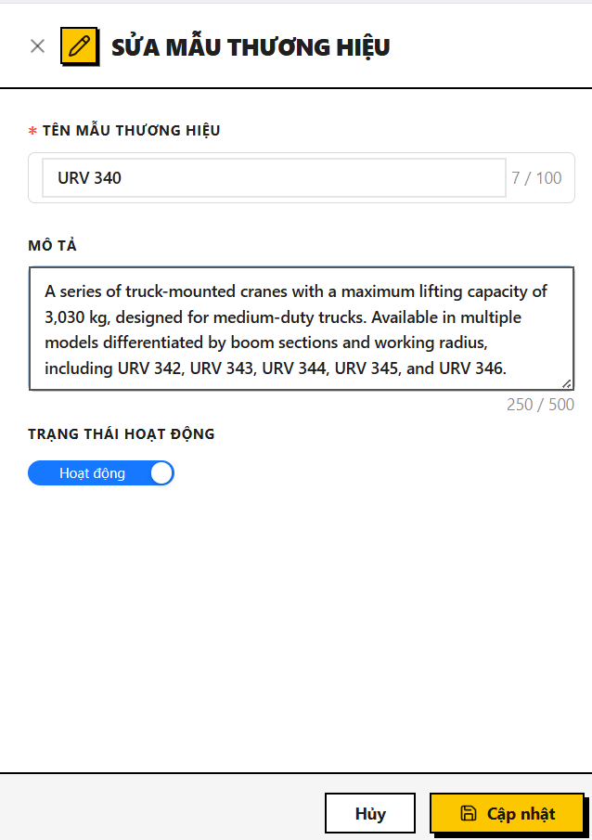

**6.1.4 Delete Brand Model (Xóa mẫu thương hiệu)**

**Description:** Allows the removal of a crane model from the active system. This action is protected by strict dependency checks to prevent breaking simulation configurations.

**Trigger:** Click the **"Xóa"** (Delete - icon thùng rác) button on a specific row.

**Usage Steps:**

1. **[Action]:** A confirmation dialog appears asking the user to confirm the deletion.
2. **Confirmation:** Click **"Xóa"** (Confirm) to proceed.
3. **Result:** The record is removed from the table view.

**System Logic (Critical Integrity Rule):**

* **Dependency Check:** Before deletion, the backend scans the SimulationComponents table.
* **Blocking Rule:** If this Brand Model is currently linked to any Simulation Component (used in physics calculations), the system **BLOCKS** the deletion and returns an error: *"Cannot delete brand model that has simulation components."*.
* **Soft Delete:** If no dependencies exist, the system performs a "Soft Delete" (sets IsDeleted = true) to preserve historical data integrity.

#### 6.2 Manage Simulation Tasks (Quản lý Nhiệm vụ Mô phỏng)

**Description:** Allows the Simulation Manager to define a library of atomic tasks (objectives) such as "Lift Cargo", "Navigate Zigzag", or "Emergency Stop". These tasks serve as building blocks that are later assigned to specific Practice Sessions.

**Trigger:** Select **"Nhiệm vụ thực hành"** (Task Practice) from the Simulation Manager Sidebar.

#### 6.3.1 View Task List

**Usage Steps:**

1. **Access:** The page loads the list of existing tasks via API GET /api/Tasks/paged.
2. **View Modes:** Users can toggle between **Table View** and **Card View** using the toggle button at the top right.
3. **Display Data:**
   * **Task Name:** Descriptive name (e.g., "Nâng hàng an toàn").
   * **Task Code:** Unique identifier (e.g., "TASK-001").
   * **Description:** Operational details.
   * **Expected Result:** The criterion for success (e.g., "Cargo placed within 5cm of target").

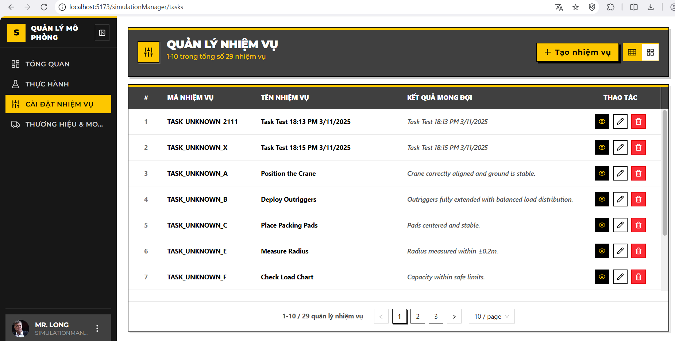

#### 6.3.2 Create New Task (Tạo mới Nhiệm vụ)

**Usage Steps:**

1. **Trigger:** Click the **"CREATE TASK"** button (or icon **+**) at the top right.
2. **Action:** A drawer form slides in titled **"CREATE NEW TASK"**.
3. **Input the required fields** :
   * **Tên nhiệm vụ (Task Name):**
     + *Validation:* Required, Max 100 chars.
   * **Mã nhiệm vụ (Task Code):**
     + *Validation:* Required, Max 50 chars, Must be unique.
     + *Example:* "LIFT-OP-01".
   * **Mô tả (Description):**
     + *Validation:* Optional, Max 500 chars.
   * **Kết quả mong đợi (Expected Result):**
     + *Validation:* Optional, Max 100 chars.
4. **Submission:** Click **"Create"** (Tạo ) to submit to POST /api/Tasks.

**System Logic (Backend Verification - TasksService.cs):**

* **Uniqueness Check:** The system verifies if TaskCode already exists (case-insensitive). If duplicated, it throws an error: *"Task code '{code}' already exists."*
* **Data Cleaning:** Automatically trims whitespace from all text inputs.

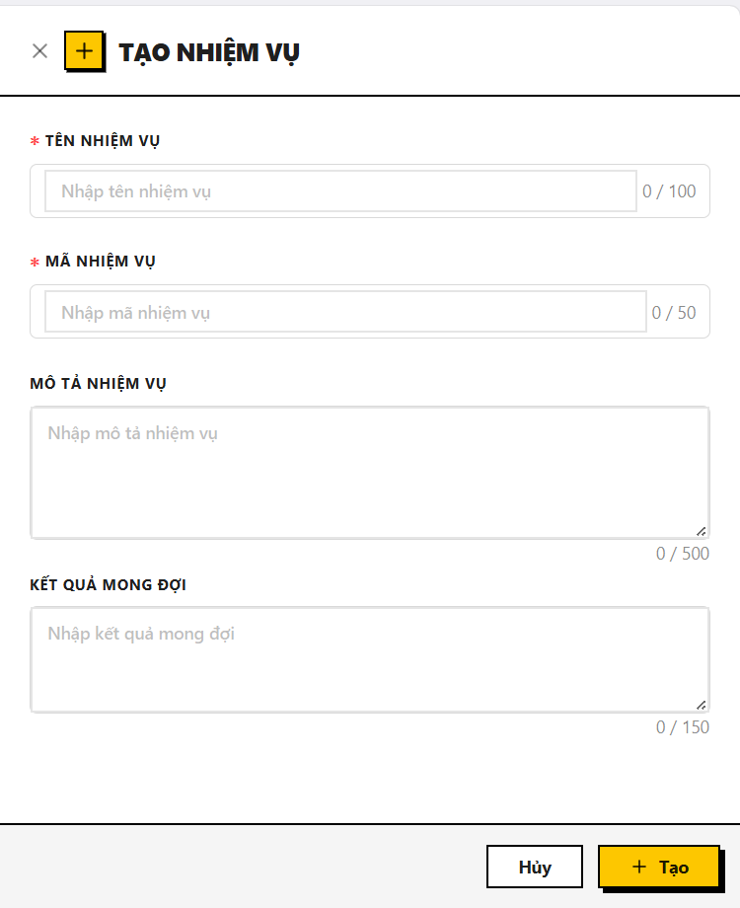

#### 6.3.3 Edit Task (Cập nhật Nhiệm vụ)

**Usage Steps:**

1. **Trigger:** Click the **"Edit"** (Pencil icon) on a task card or table row.
2. **Action:** The drawer opens with title **"EDIT TASK"**, pre-filled with current data.
3. **Modification:** Update fields as needed. Note that TaskCode can be changed but must remain unique across the system.
4. **Submission:** Click **"Update"** to save changes (PUT /api/Tasks/{id}).

**Business Rules:**

* **Self-Exclusion Check:** When checking for duplicate TaskCode, the system ignores the current task being edited.

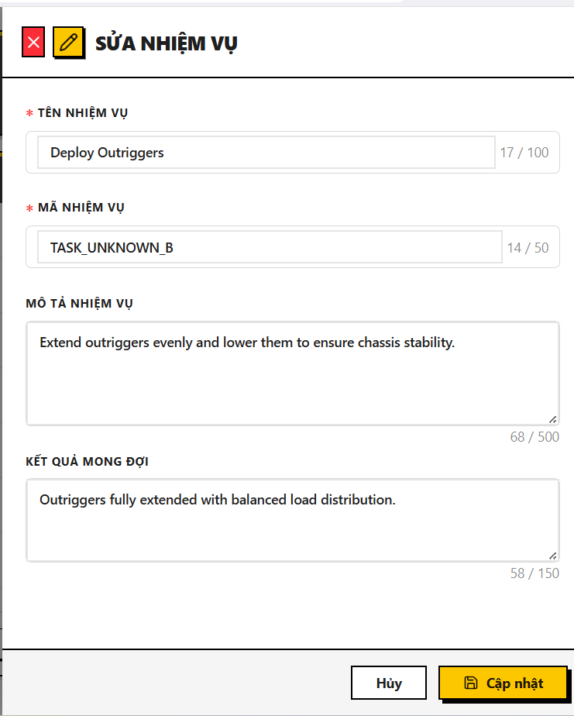

#### 6.3.4 Delete Task (Xóa Nhiệm vụ)

**Usage Steps:**

1. **Trigger:** Click the **"Delete"** (Trash icon) on a task.
2. **Confirmation:** A modal appears: *"Are you sure you want to delete {taskName}?"*.
3. **Action:** Click **"Delete"** to confirm.

**System Logic (Critical Integrity Rule):**

* **Dependency Block:** The backend (TasksService.cs) checks if this Task is currently assigned to any Practice Scenario (PracticeTasks table).
* **Rule:** If the task is in use, the system **BLOCKS** the deletion and returns an error: *"Cannot delete a task associated with one or more practices."*
* **Soft Delete:** If safe to delete, the system sets IsDeleted = true.

### 6.4 Manage Simulation Practices (Quản lý Bài Thực hành Mô phỏng)

**Description:** Allows Simulation Managers to define complete practice scenarios by combining metadata (Duration, Difficulty) with specific operational tasks. These practices are the core content assigned to trainees for simulation training.

**Trigger:** Select **"Bài thực hành"** (Practices) from the Simulation Manager Sidebar.

**URL:** /simulation-manager/practices

#### 6.4.1 View Practice List

**Usage Steps:**

1. **Access:** Upon loading the page, the system automatically fetches the list of existing practices.
2. **Display Data:** The table displays the following information:
   * **Mã bài thực hành (Practice Code):** Unique identifier for the scenario (e.g., "PRAC-001").
   * **Tên bài thực hành (Practice Name):** The descriptive title of the practice (e.g., "Vận hành cẩu cơ bản").
   * **Thời lượng (Duration):** Estimated time required to complete the practice (in minutes).
   * **Độ khó (Difficulty):** The skill level required, visualized by color-coded badges:
     + *Entry* (Easy/Green)
     + *Intermediate* (Medium/Yellow)
     + *Advanced* (Hard/Red)
   * **Số lần thử (Max Attempts):** The maximum number of retries allowed for a trainee.
   * **Trạng thái (Status):** Indicates availability (*Active* / *Inactive*).
3. **Actions:** Users can click the **Edit icon** (Eye/Pencil) to view details or the **Delete icon** (Trash bin) to remove a practice.

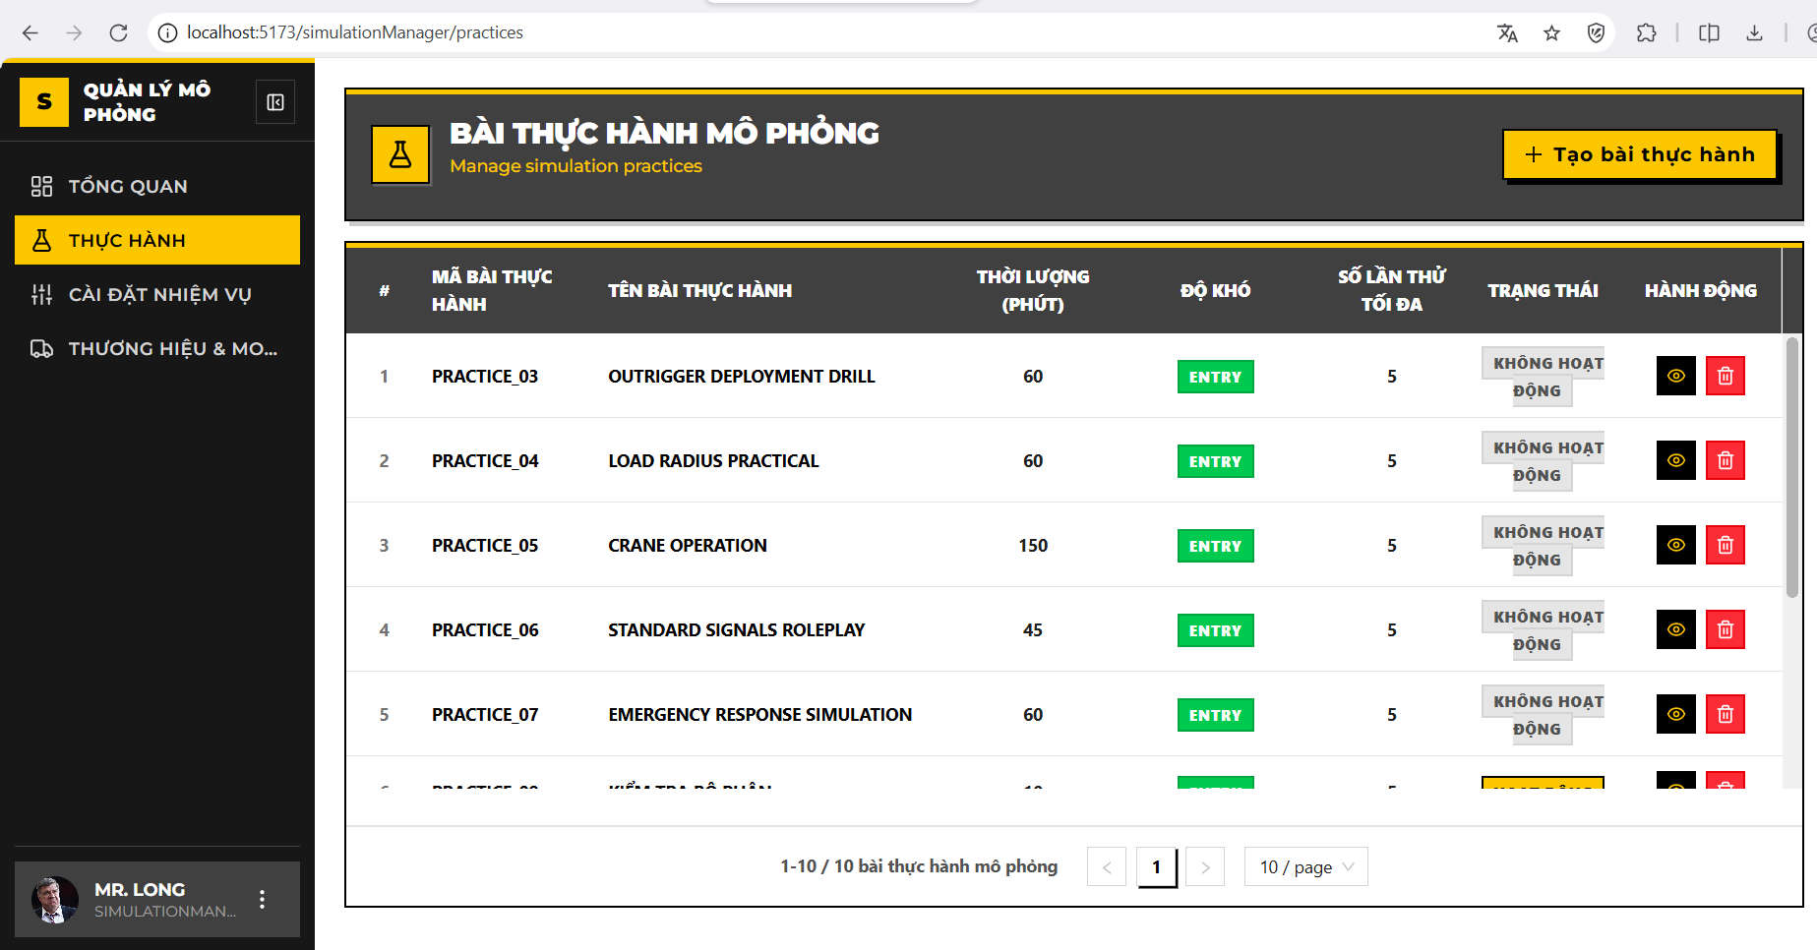

#### 6.4.2 Create New Practice (Tạo mới Bài thực hành)

**Usage Steps:**

1. **Trigger:** Click the **"Tạo mới"** (Create) button (icon **+**) at the top-right corner of the page.
2. **[Action]:** The system navigates to the Create Practice form (/practices/create).
3. **Input the required fields** :
   * **Tên bài thực hành (Practice Name):**
     + *Input:* Text field.
     + *Validation:* Required, max 200 characters.
   * **Mã bài thực hành (Practice Code):**
     + *Input:* Text field.
     + *Validation:* Required, max 50 characters, must be uppercase and unique.
   * **Mô tả (Description):**
     + *Input:* Text Area.
     + *Validation:* Optional, max 1000 characters.
   * **Thời lượng (Duration):**
     + *Input:* Number field.
     + *Unit:* Minutes.
   * **Độ khó (Difficulty):**
     + *Input:* Dropdown menu.
     + *Options:* *Entry, Intermediate, Advanced*.
   * **Số lần thử (Max Attempts):**
     + *Input:* Number field.
     + *Constraint:* Must be between 1 and 10.
   * **Trạng thái (Active):**
     + *Input:* Toggle Switch.
     + *Default:* Active (On).
4. **Submission:** Click **"Tạo bài thực hành"** (Save) to submit the data.

**System Logic (Backend Verification):**

* **Duplicate Check:** The system verifies if the PracticeCode already exists in the database. If a duplicate is found, it returns an error: *"Practice code already exists."*

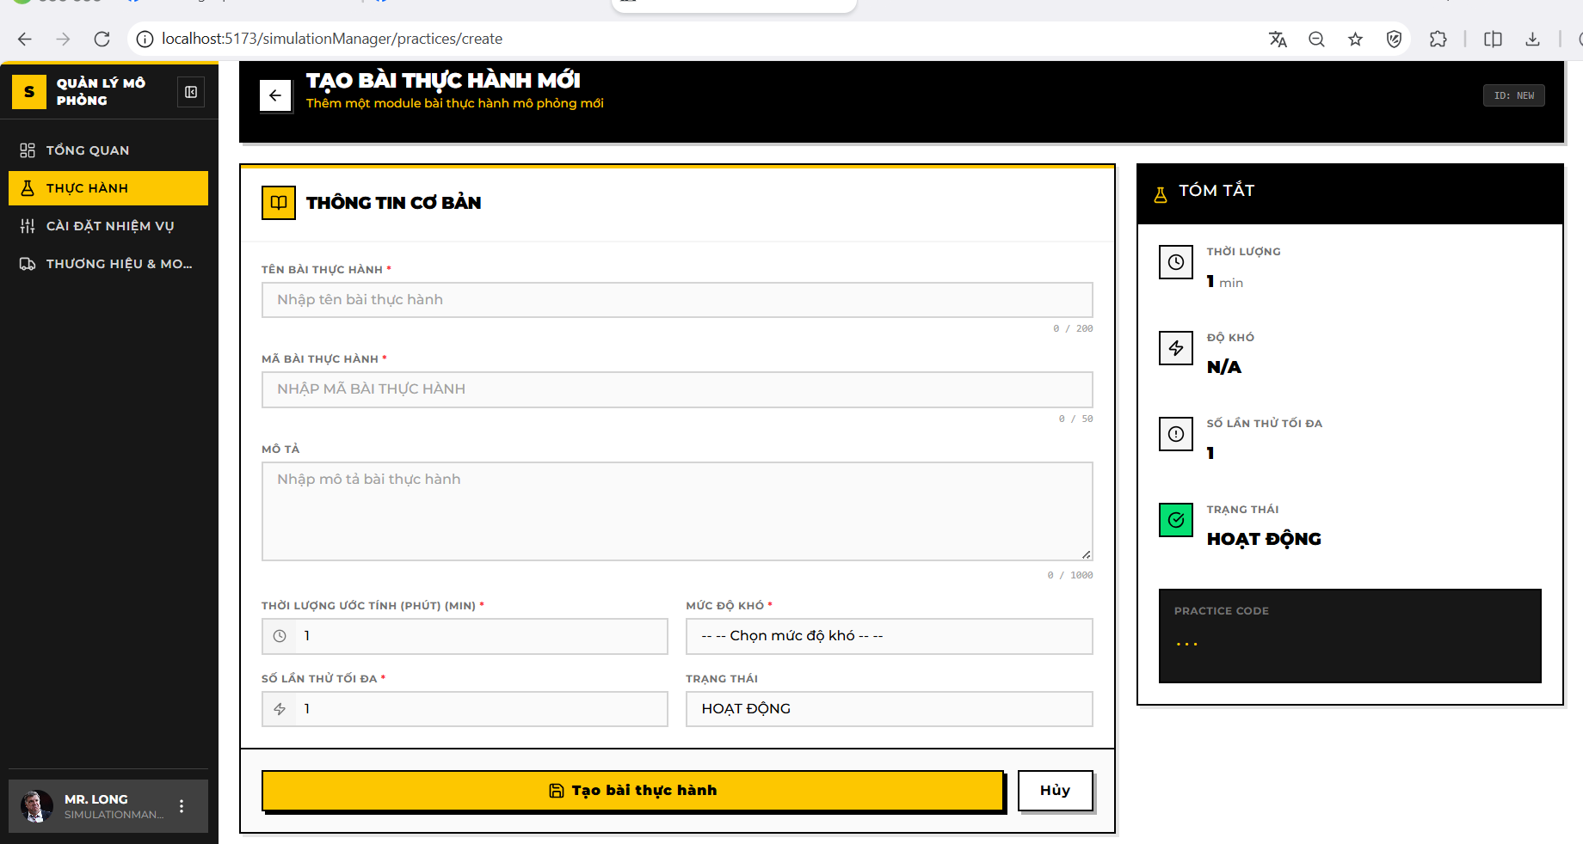

#### 6.4.3 Edit Practice & Manage Tasks (Cập nhật & Gán Nhiệm vụ)

**Description:** This interface allows updating practice metadata and assigning specific operational tasks (from the Task Library) to the practice.

**Trigger:** Click the **"Chi tiết"** (View/Edit) button on a specific row in the list.

**Usage Steps:**

**A. Edit General Information:**

1. Modify the fields in the **"Thông tin cơ bản"** (Basic Information) section.
2. Click **"Lưu thay đổi"** (Save Changes) to update the metadata.

**B. Assign Tasks (Task Configuration):**

1. **Trigger:** Scroll to the **"Danh sách nhiệm vụ"** (Task List) section and click **"Thêm nhiệm vụ"** (Add Task / Assign Task).
2. **Selection:** A modal appears listing available tasks from the library.
3. **Action:** Check the boxes next to the desired tasks (e.g., "Nâng hàng", "Di chuyển zig-zag").
   * *Note:* Tasks already assigned to this practice are hidden or disabled to prevent duplicates.
4. **Confirm:** Click **"Gán"** (Assign) to link the selected tasks to the practice.
5. **Remove Task:** To unassign a task, click the **Delete icon** on the specific task row within the list.

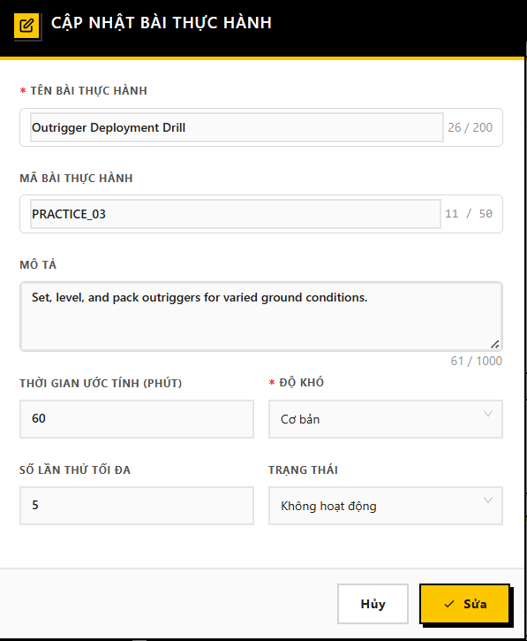

#### 6.4.4 Delete Practice (Xóa Bài thực hành)

**Usage Steps:**

1. **Trigger:** Click the **"Xóa"** (Delete) button (icon Trash bin) on a specific row in the main list.
2. **Confirmation:** A dialog appears asking: *"Bạn có chắc chắn muốn xóa bài thực hành này?"* (Are you sure you want to delete this practice?).
3. **Action:** Click **"Xóa"** (Confirm) to proceed.

**System Logic (Integrity Check):**

* **Dependency Block:** The backend checks if this Practice is currently linked to any active **Training Curriculum** (Activities).
* **Rule:** If the practice is in use, the system **BLOCKS** the deletion to prevent breaking the course structure.

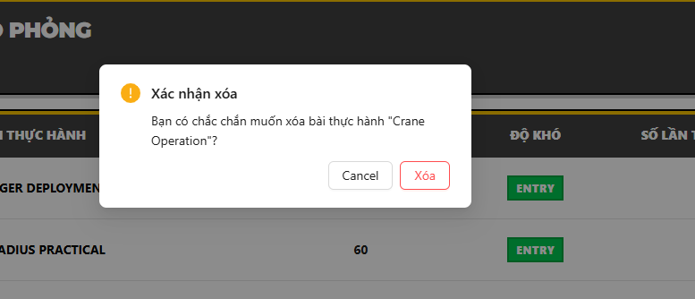

### 6.5 Simulation Manager Dashboard (Bảng điều khiển quản lý mô phỏng)

**Description:** Provides a comprehensive analytical view of the simulation training system. It aggregates real-time data regarding trainees, practice scenarios, and system usage to help managers assess training throughput and effectiveness.

**Trigger:** Select **"Tổng quan"** (Dashboard) from the Simulation Manager Sidebar.

**URL:** /simulation-manager/dashboard

#### 6.5.1 System Overview Statistics (Thống kê tổng quan)

**Usage Steps:**

1. **Access:** Upon accessing the dashboard, the top section ("StatsOverview") automatically loads data from the server.
2. **Display Data:** Four key metric cards are displayed:
   * **Tổng học viên (Total Trainees):** Total number of active trainees in the system.
   * **Tổng thực hành (Total Practices):** Total number of practice scenarios defined.
   * **Tổng nhiệm vụ (Total Tasks):** Total number of atomic tasks available in the library.
   * **Tổng phiên mô phỏng (Total Simulation Sessions):** Cumulative count of all practice attempts made by trainees.

**System Logic (Backend Analysis - SimulationManagerDashboardService.cs):**

* **Data Aggregation:** The system queries the database using CountAsync filters.
* **Exclusion Rule:** All queries strictly filter out deleted records (IsDeleted == false) to ensure accuracy.
* **Role Validation:** The backend enforces a security check to ensure the requesting user has the SimulationManager role before returning data.

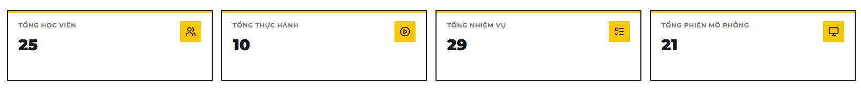

#### 6.5.2 Monthly Practice Completion Analytics (Phân tích hoàn thành thực hành)

**Description:** A chart visualization showing the trend of successful vs. failed practice attempts over the months of a selected year.

**Usage Steps:**

1. **View Chart:** A bar chart displays two datasets per month:
   * **Completed (Hoàn thành):** Number of attempts where the trainee passed (IsPass == true).
   * **Not Completed (Chưa hoàn thành):** Number of attempts failed (IsPass == false).
2. **Filter by Year:** Use the year selector (Dropdown/Input) at the top of the chart to change the reporting period (Default is the current year).

**System Logic:**

* **API Call:** GET /api/simulation-manager/dashboard/completion-distribution?year={year}.
* **Grouping:** Data is aggregated from the PracticeAttempts table, grouped by Month.
* **Metric Definition:** "Completion" is strictly defined by the IsPass boolean flag in the database attempt record.

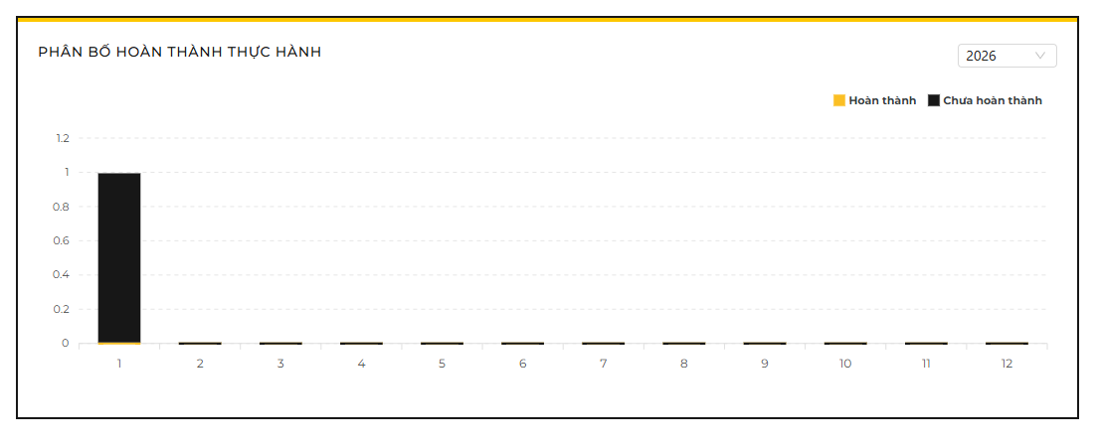

#### 6.5.3 Practice Duration Distribution (Phân bổ thời lượng thực hành)

Description:

A pie/donut chart categorizing simulation sessions based on the complexity/length of the practices being attempted. This helps managers understand if trainees are focusing on short drills or long, complex scenarios.

**Usage Steps:**

1. **View Distribution:** The chart segments usage into three categories:
   * **Fast (< 15 mins):** Short exercises.
   * **Moderate (15-45 mins):** Standard training sessions.
   * **Slow (> 45 mins):** Long/Complex scenarios.
2. **Interaction:** Hover over chart segments to see the exact count of trainees/attempts in each category.

**System Logic (Code Insight):**

* **Classification Source:** The category is determined by the **Estimated Duration** (EstimatedDurationMinutes) defined in the *Practice configuration*, not the actual time the student spent.
  + *Logic:* Join(PracticeRepository) Check EstimatedDuration.
* **Buckets:**
  + Fast: Duration < 15.
  + Moderate: 15 <= Duration <= 45.
  + Slow: Duration > 45.

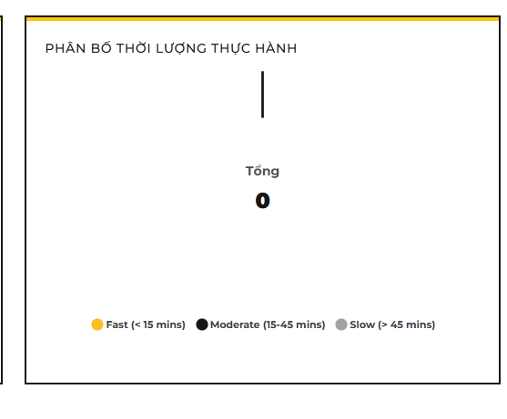

#### h. Feature 7: Training Program Management (Quản lý chương trình đào tạo)

**Description:** This feature serves as the backbone of the training curriculum. It allows the Administrator to define high-level "Training Programs" (e.g., "Crane Operation 2025") and structure them by grouping multiple specific "Courses" (e.g., Theory, Basic Sim, Advanced Sim). It includes advanced tools for bulk data import to set up complex curriculums quickly.

**Trigger:** Select "Programs" (Chương trình đào tạo) from the Admin Sidebar menu.

**URL:** /admin/programs

### 7.1 Program List & Creation (Danh sách & Tạo mới chương trình)

**Usage Steps:**

1. **Access:** Upon accessing the page, the system loads the list of existing training programs into a data grid.
2. **Create New:** Click the **"Create Program"** button. A drawer form appears.
3. **Input Data:** Enter the required fields:
   * **Program Code:** Unique identifier (e.g., PROG-2025).
   * **Program Name:** Display name of the curriculum.
   * **Description:** Detailed objectives of the program.
4. **Save:** Click "Submit" to persist the new program.

**System Logic (Backend Analysis - ProgramsController.cs & ProgramsService.cs):**

* **Data Retrieval:** The GetPrograms endpoint uses PagedResult to fetch data efficiently, supporting server-side filtering and sorting.
* **Uniqueness Validation:** Before creation, the system checks the database (_unitOfWork.Programs) to ensure the ProgramCode is unique. If a duplicate exists, it throws a 409 Conflict exception.
* **Entity Creation:** A new TrainingProgram entity is initialized with Status = Active by default upon creation.

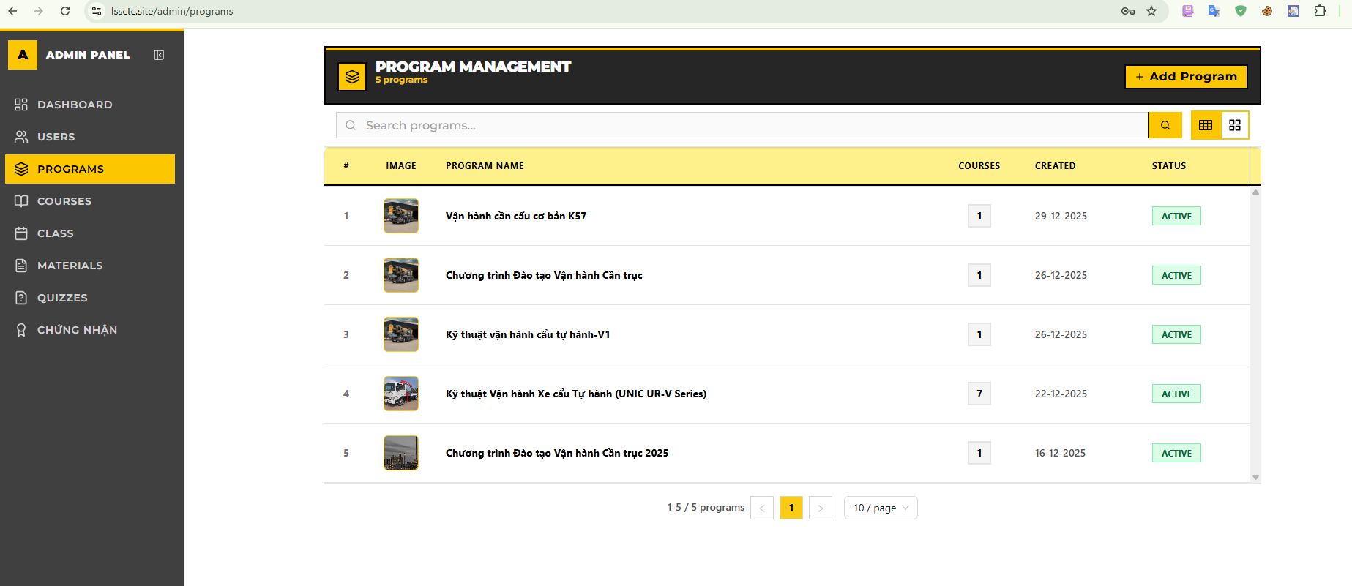

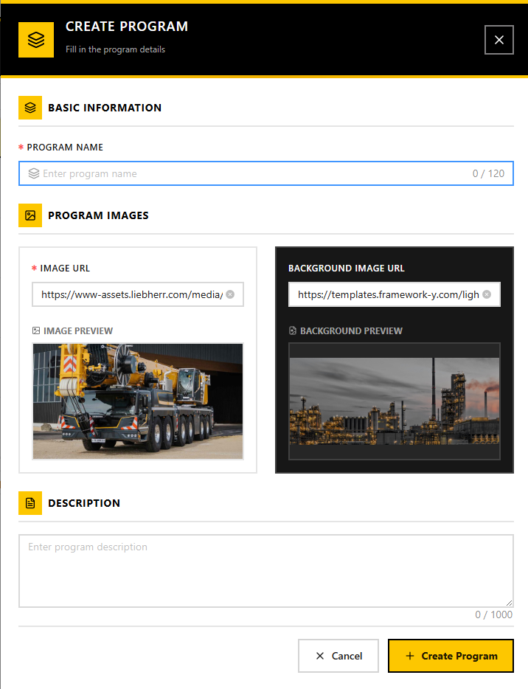

### 7.2 Curriculum Configuration - Assign Courses (Cấu hình khung chương trình)

**Usage Steps:**

1. **View Detail:** Click on a Program Name to enter the **Program Detail Page** .
2. **Navigate:** Switch to the **"Curriculum"** (Khung chương trình) tab.
3. **Add Course:** Click **"Add Course"**. A modal appears listing all active courses in the system.
4. **Selection:** Select one or multiple courses (e.g., "Safe Operation Theory", "Basic Lifting Practice") and confirm.
5. **Re-ordering:** The assigned courses appear in the list. Admin can remove incorrectly assigned courses.

**System Logic (Backend Analysis - ProgramCoursesService.cs):**

* **Relationship Mapping:** The system does not just link IDs; it creates records in the ProgramCourse joining table (Many-to-Many relationship).
* **Validation:** The backend verifies that the selected CourseId exists and is Active. It also prevents adding the same course twice to the same program to avoid circular dependencies or duplication.
* **Cascade Logic:** When a Program is loaded for a Trainee, the system uses this mapping to fetch all associated Courses and their respective Progress trackers.

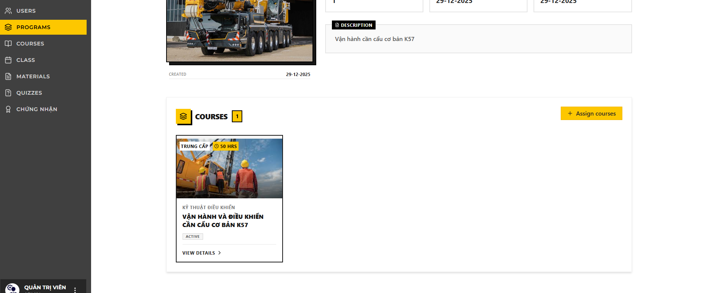

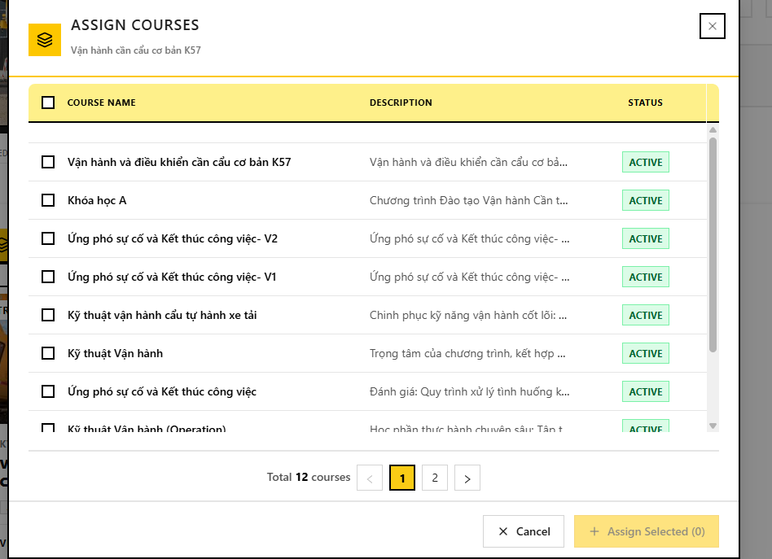

### 7.3 Bulk Import from Excel (Import chương trình từ Excel)

**Usage Steps:**

1. **Trigger Import:** On the Program List page, click the **"Import Excel"** button.
2. **Download Template:** Click to download the standard .xlsx template provided by the system.
3. **Prepare Data:** Fill in the Excel file. Key columns usually include ProgramCode, ProgramName, and CourseCode (to automatically link courses).
4. **Upload & Process:** Upload the file. The system previews the valid and invalid rows.
5. **Confirm:** Click "Import" to commit the valid data to the database.

**System Logic (Backend Analysis - ProgramImportService.cs):**

* **File Parsing:** Uses a library (likely EPPlus or NPOI) to read the uploaded stream.
* **Two-Layer Validation:**
  + *Syntax:* Checks if required columns exist and data types are correct.
  + *Business Logic:* It verifies if the linked CourseCode inside the Excel file actually exists in the DB.
* **Transactional Integrity:** The import is wrapped in a DbTransaction. If an error occurs during the linking process (e.g., a Course is missing), the entire batch for that specific program is rolled back to prevent "orphan" or partial data states.

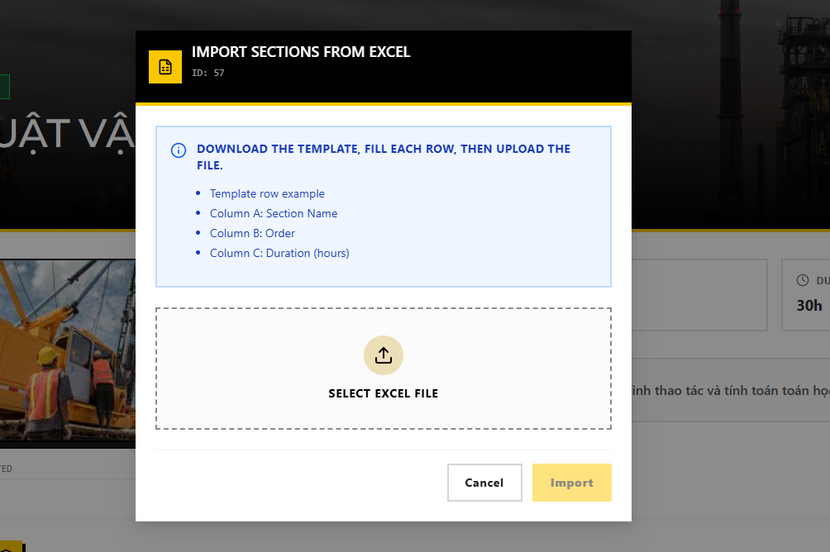

#### i. Feature 8: Trainee Learning Portal

**Overview:** This feature serves as the primary interface for trainees to engage with the training program. It consolidates daily schedules, course materials (video/documents), simulation practice tracking, assessments, and certification. The system enforces progression rules (e.g., video completion triggers) to ensure training integrity.

**Actor:** Trainee **Pre-condition:** User must be logged in successfully with the **Trainee** role.

#### 8.1 View Weekly Schedule (Lịch học)

**Description:** Allows trainees to view their assigned class sessions. The system organizes time slots into a weekly grid view, helping trainees track upcoming theory lessons or simulation practice sessions. **Trigger:** Select "Lịch học" (Schedule) from the Sidebar. **URL:** /trainee/schedule

**Usage Steps:**

1. **View Weekly Grid:**
   * The interface calculates the current week (starting Monday) and displays a calendar grid.
   * Columns represent days (Monday - Sunday), and rows represent assigned Time Slots (e.g., Slot 1: 07:00 - 09:15).
   * [System Logic]: The system calls GET /api/timeslots/trainee/weekly with the dateInWeek parameter to fetch relevant sessions.
2. **Navigation:**
   * Click the **"<" (Previous)** or **">" (Next)** buttons to navigate between weeks.
   * Click "Hôm nay" (Today) to return to the current week.
3. **Session Details:**
   * Occupied slots display the Class Name, Room/Lab location, and Attendance Status (e.g., "Present", "Absent").

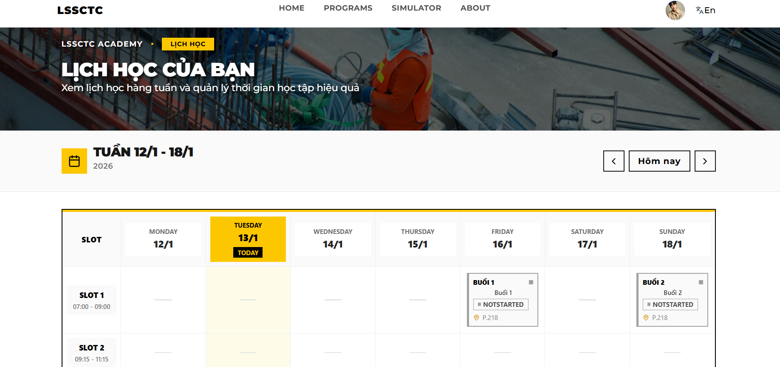

#### 8.2 Learn Course Material (Học tập)

**Description:** The core learning interface where trainees consume lecture videos and reading materials. The system tracks engagement time and automatically updates progress status based on specific completion thresholds. **Trigger:** Select a specific Class > Course > Section > Activity from the "Program" menu. **URL:** /trainee/learn/:courseId/:sectionId/:partitionId

**Usage Steps:**

1. **Access Content:**
   * The sidebar displays the course curriculum tree (Sections and Activities).
   * Click on a "Video" or "Document" activity to load the content.
2. **Watch Video (Video Material):**
   * The embedded video player loads the lecture URL (supports YouTube integration).
   * [Constraint]: The system monitors the timeUpdate event.
   * [Business Rule]: The activity is marked as **"Completed"** only when the viewing progress reaches **≥ 95%**. A notification " User watched the video completely" is logged, and the status is synced to the backend.
3. **Read Document:**
   * For PDF/Text materials, the interface displays the content directly.
   * Click the "Hoàn thành" (Mark as Done) button (if manual completion is enabled) to update progress.

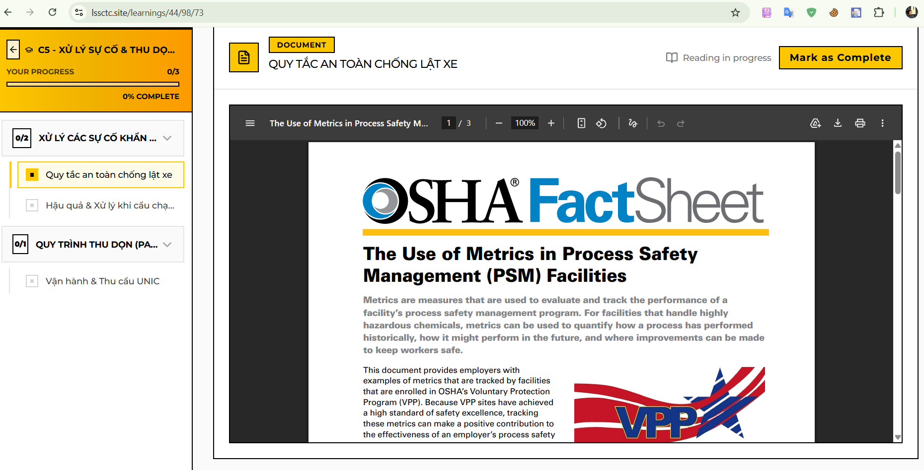

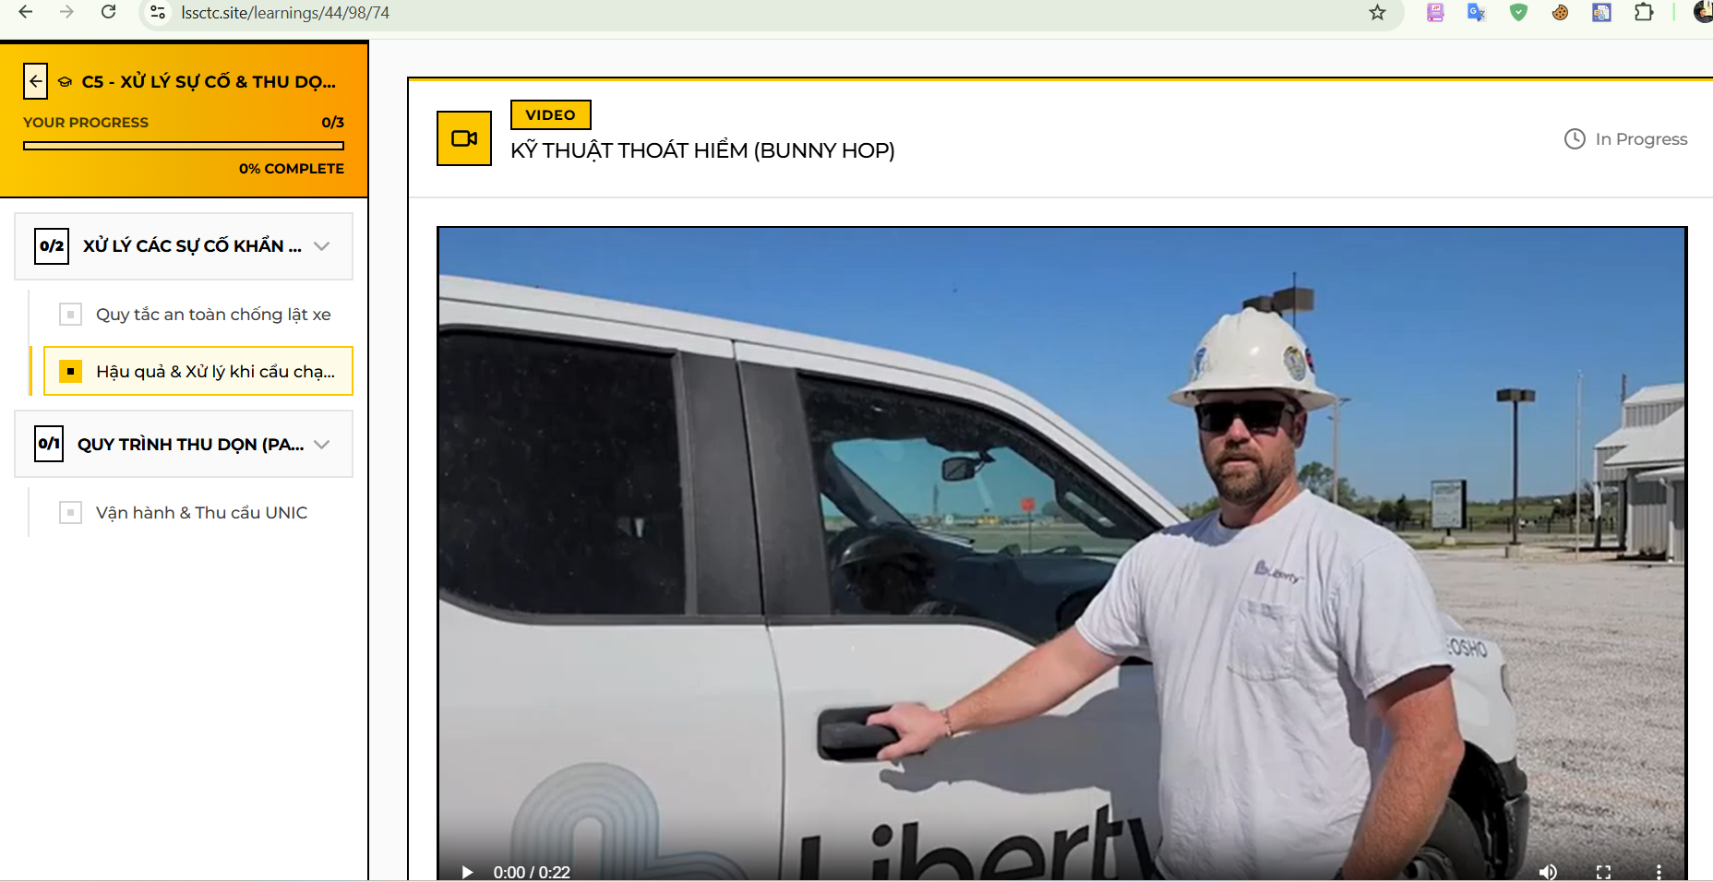

#### 8.3 Take Quiz (Làm bài kiểm tra)

**Description:** Trainees take multiple-choice assessments to validate their knowledge. The system manages attempt limits, calculates scores in real-time, and provides immediate feedback. **Trigger:** Select a "Quiz" activity from the Course Sidebar. **URL:** /trainee/learn/.../quiz/:quizId

**Usage Steps:**

1. **View Quiz Info:**
   * The start screen displays: Quiz Title, Description, Time Limit, and Remaining Attempts (calculated via MaxAttempts - CurrentAttempts).
2. **Attempt Quiz:**
   * Click "Bắt đầu làm bài" (Start Quiz).
   * Select answers for each question. The system supports Single Choice and Multiple Choice formats.
   * A countdown timer (HeaderTimer) tracks the remaining time.
3. **Submit & Review:**
   * Click "Nộp bài" (Submit). The system calculates the score based on: (Correct Answers / Total Questions) * 10.
   * **Pass/Fail Logic:** If Score ≥ PassingScore, the activity status updates to "Passed".
   * The "Result" screen displays the final score and allows reviewing answers (if configured).

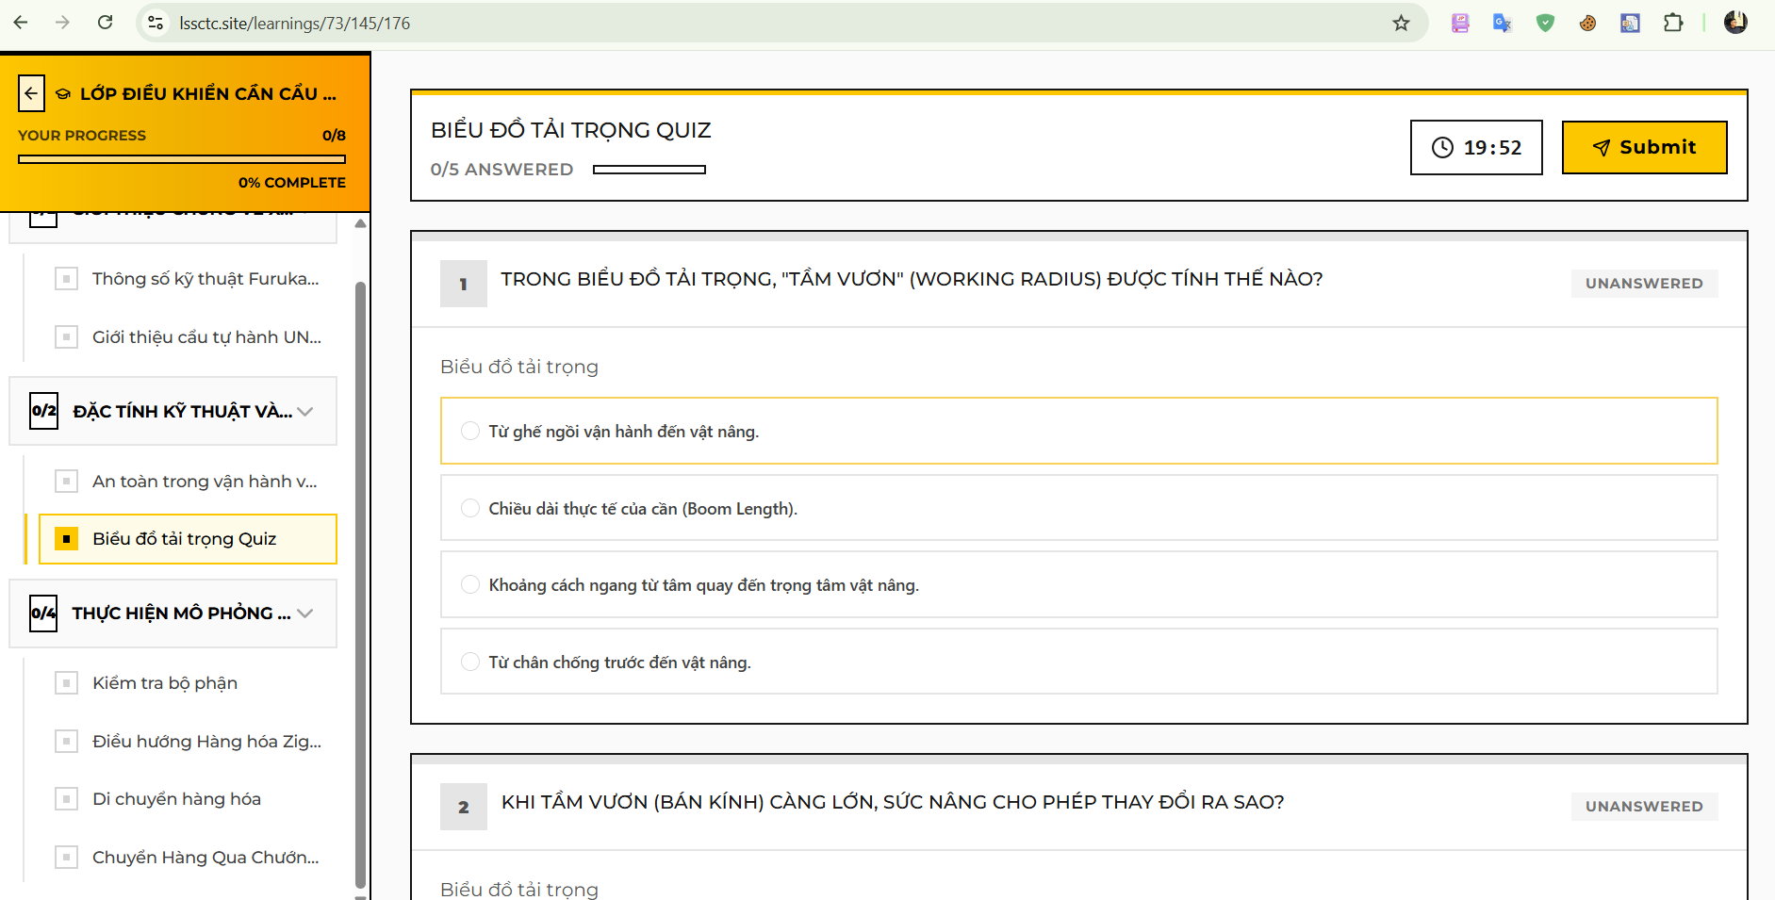

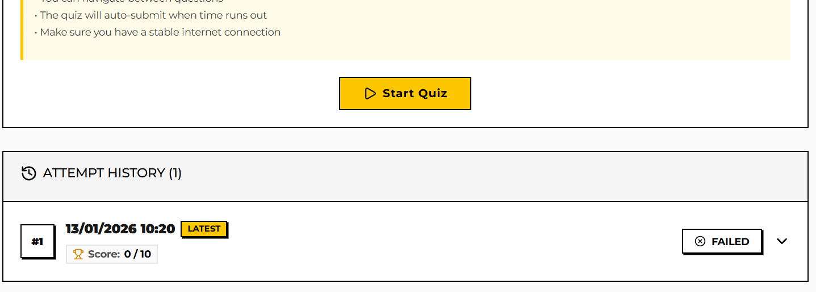

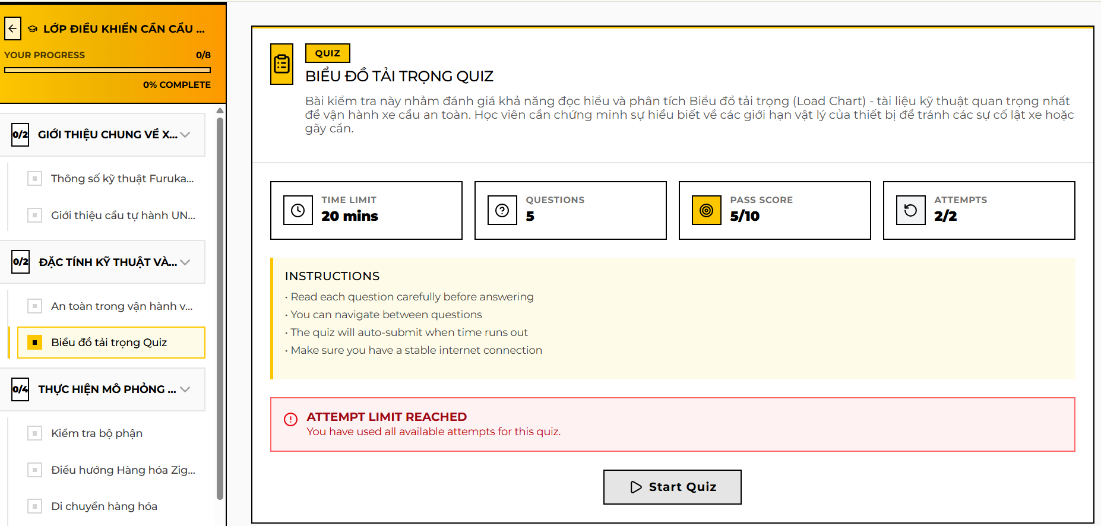

#### 8.4 View & Download Certificate (Chứng chỉ)

**Description:** A digital repository of all certifications earned by the trainee upon completing courses. It provides visual indicators for certificate validity and allows downloading the official certificate file. **Trigger:** Select "Chứng chỉ" (Certificates) from the Sidebar. **URL:** /trainee/certificates

**Usage Steps:**

1. **View List:**
   * The page displays cards for each earned certificate containing: Course Name, Issue Date, and Expiration Date.
2. **Check Status (Visual Indicators):**
   * **Valid:** Displayed with a **Yellow/Standard** badge if the expiration date is far in the future.
   * **Expiring Soon:** Displayed with an **Amber** badge if the certificate expires in less than **90 days**.
   * **Expired:** Displayed with a **Red** badge if ExpireDate < CurrentDate.
3. **Download:**
   * Click the "Download" or "View" button to retrieve the generated PDF certificate from the backend.



### 3.4 Troubleshooting